**CARE CONNECT PROJECT THESIS SUBMITTED**

**TO**

**AWH ENGINEERING COLLEGE KUTTIKKATTOOR, KOZHIKODE**

### IN PARTIAL FULFILMENT

**OF THE REQUIREMENTS FOR THE AWARD OF THE DEGREE**

**OF**

**Master Of Computer Applications**

#### BY

**VARNA VINOD**



### DEPARTMENT OF COMPUTER APPLICATIONS AWH ENGINEERING COLLEGE KUTTIKKATTOOR,

**KOZHIKODE**

**MAY 2024**

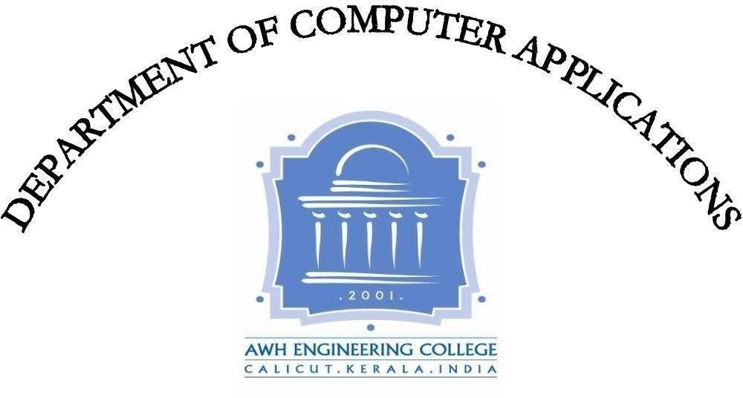

**AWH ENGINEERING COLLEGE**

KOZHIKODE

#### CERTIFICATE

#### This is to certify that this thesis entitled *“CARE CONNECT” submitted herewith is an authentic record of the thesis work done by VARNA VINOD (AWH22MCA-2045) under our guidance in partial fulfillment of the requirements for the award of Master of Computer Applications from APJ Abdul Kalam Technological University during the academic year 2023.*

#### Mrs.Sruti Sudevan Mrs.Sruti Sudevan

Assistant Professor Assistant Professor

Dept. of Computer Applications Dept. of Computer Applications Head of the department Project guide

**External Examiner Internal Examiner**

### ACKNOWLEDGEMENT

I express my sincere gratitude to our beloved principal **Dr.Sabeena M V** for providing me an opportunity with the required facilities for doing this project. I express my hearty thanks to **Mrs.Sruti Sudevan,** Head of the department of Computer Applications for her guidance. I am thankful to all other staff of the MCA department for their encouragement, timely guidance, valuable suggestions and inspiring ideas given throughout this project. I am grateful to my friends for the way they have cooperated, expected me to achieve success and have always stirred my ambition to do the best. Above all, I am grateful to the almighty, who has showered His blessings on me throughout my life and throughout the project.

**VARNA VINOD**

### ABSTRACT

"Care Connect" is a digital platform designed for a seamless connection between users willing to donate used items and charitable organizations, with a primary focus on orphanages. Users can upload items like clothing, bags, and books, while Charity Organizations, acting as intermediaries, can collect these items. This initiative creates a collaborative environment where Orphanages can directly communicate their specific needs to Charity Organizations. Upon request, the organizations deliver the required items to the orphanages. Care Connect bridge the gap between surplus resources and those in need, providing a user-friendly interface for individuals, charitable organizations, and orphanages to interact and contribute to the well-being of community. This innovative solution not only promotes sustainability by recycling used items but also establishes a network of care and support, creating a positive impact on the lives of those less fortunate

.

**CONTENTS**

Page No

1. INTRODUCTION 1
2. SYSTEM ANALYSIS 3
   1. Existing System 4
   2. Proposed System 4
   3. Module Description 5
   4. Sprint 8
   5. User stories 12
3. FEASIBILITY STUDY 13
   1. Economical Feasibility 14
   2. Technical Feasibility 14
   3. Operational Feasibility 14
   4. Behavioral Feasibility 14
   5. Software Feasibility 15
   6. Hardware Feasibility 15
4. SOFTWARE ENGINEERING PARADIGM 16
   1. Agile Model 17
   2. Scrum 17
5. SYSTEM REQUIREMENT SPECIFICATIONS 20
   1. Software Requirements 21
   2. Hardware Requirements 21
6. SYSTEM DESIGN 22
   1. Mongo DB 23
   2. Collections 23
   3. UML Design 24
   4. Use Case Diagram 25
   5. Scenario 27
   6. Sequential Diagram 30

7.SYSTEM DEVELOPMENT 38

7.1 Coding 38

8.SYSTEM TESTING AND IMPLEMENTATION 41

8.1 Types of Testing 42

8.2 Implementation 42

9.SYSTEM MAINTENANCE 43

10.FUTURE ENHANCEMENT 45

11.CONCLUSION 47

12.APPENDIX 49

13.BIBLIOGRAPHY 79

# INTRODUCTION

### INTRODUCTION

In today's society, many of us have items lying around our homes, unused and waiting to find a new purpose. But people find it difficult to find time to help others .And people also people feel like their small donations won't make a difference, especially when they see orphanages with lots of kids. And with their busy lives, it's hard to visit organizations to see what they need. "Care Connect" addresses this challenge by providing a user-friendly interface where users can easily upload items such as clothing, bags, and books, initiating a cycle of generosity and support.

Acting as intermediaries, charitable organizations play a crucial role in this , ensuring that donated items find their way to those who need them the most. Through "Care Connect," orphanages can communicate their specific needs directly to these organizations,providing a collaborative environment where surplus resources meet the needs of the community.Beyond the simple act of donation, "Care Connect" promotes sustainability by encouraging the recycling of used items, making a positive impact on the environment. Moreover, it establishes a network of care and support, connecting individuals, organizations, and orphanages in a shared mission to uplift and empower those less fortunate.

With its user-friendly interface and innovative approach, "Care Connect" bridges the gap between surplus resources and those in need, providing a platform where every contribution, no matter how small, makes a meaningful difference in the lives of others.

# SYSTEM ANALYSIS

### SYSTEM ANALYSIS

#### Existing system

In the current system, both charitable organizations and users encounter significant challenges in the donation process. Charitable organizations find it difficult to collect donated items efficiently, often relying on manual and time-consuming methods. Simultaneously, users struggle to identify the specific needs of orphanages and face difficulties finding time in their busy schedules to physically visit orphanages for delivering the donated products. These obstacles create a barrier to seamless and timely assistance, impacting the effectiveness of the overall donation process and leaving both donors and recipients feeling frustrated and disconnected.

The existing system has several disadvantages:

* Charitable organizations face difficulty in efficiently collecting donated items.
* Users struggle to determine the exact needs of orphanages .

#### Proposed system

The proposed system aims to revolutionize the current donation landscape by introducing a user-friendly platform tailored to address the identified challenges comprehensively. Charitable organizations are poised to benefit significantly from a more streamlined collection process, made possible through dedicated delivery services. This ensures not only the efficient handling of donated items but also alleviates the burdensome logistics involved in traditional collection methods. Meanwhile, users stand to experience a vastly simplified and convenient donation process, allowing them to effortlessly upload item details and arrange for pickups directly from their homes. This seamless integration not only saves time but also encourages greater participation in the act of giving. Furthermore, the platform establishes transparent communication channels between orphanages and organizations, fostering a collaborative environment that enhances the overall efficiency, accessibility, and impact of the donation process. By bridging gaps and facilitating meaningful connections, this innovative solution promises to elevate the collective effort towards addressing societal needs and fostering positive change within communities.

The proposed system has several advantages:

* + - Streamlined collection process for organizations.
    - Simplified donation process for users
    - Time saving for users.

#### Module Description

This project has 5 modules:

##### Admin:

* Login
* Manage organization
* Manage orphanages
* View users
* View products
* View reports
* View financial contributions
* View events
* View donations
* View reviews
* View sponsorships
* View orders
* View delivery boys

##### Organization:

* Register
* Login
* Manage delivery boy
* View and accept/reject donation requests
* View orphanages
* View products
* Add products to cart
* View cart
* Order products
* View orders
* Add/View reports
* View events
* Send, view sponsorship request
* View, edit profile

##### View review

##### Orphanage:

* Register
* Login
* View organization
* Send, view donation request
* View donations
* View financial contributions from users
* Add /view events
* View, accept/reject sponsorship requests
* View reports
* Post ,view review
* View, edit profile
* Sent financial contribution request

##### User:

* Register
* Login
* View, edit profile
* Upload product
* View product
* View organizations
* View orphanages
* View, accept/reject order request
* View orders
* Do financial contribution to orphanages
* View contribution history
* View events
* View reports
* View reviews

##### Delivery boy:

* Login
* View, edit profile
* Update order delivery status
* View, update donation status
* View orders
* Verify products

#### Sprint

#### Sprint 1

|  |  |  |  |  |  |
| --- | --- | --- | --- | --- | --- |
| Module | Task | Hours for completion | Expected date of completion | Actual date of completion | Reason for Deviation |
| Admin/Organization/Orphanage/User/Delivery boy | Login | 5 hours | 29/01/2024 | 29/01/2024 | - |
| Admin | Manage Organization | 4 hours | 30/01/2024 | 30/01/2024 | - |
| Manage orphanage | 4 hours | 31/01/2024 | 31/01/2024 | - |
| View products | 3 hours | 1/02/2024 | 1/02/2024 | - |
| View contribution | 3 hours | 1/02/2024 | 1/02/2024 | - |
| View sponsorships | 2 hours | 02/02/2024 | 02/02/2024 | - |
| View donation | 2 hours | 02/02/2024 | 02/02/2024 | - |
| View order | 3 hours | 03/02/2024 | 03/02/2024 | - |
| View report | 2 hours | 05/02/2024 | 05/02/2024 | - |
| View events | 2 hours | 05/02/2024 | 05/02/2024 | - |

#### Sprint 2

|  |  |  |  |  |  |
| --- | --- | --- | --- | --- | --- |
| Module | Task | Hours for completion | Expected date of completion | Actual date of completion | Reason for Deviation |
| Admin | View user | 2 hours | 06/02/2024 | 06/02/2024 | - |
| View review | 2 hours | 06/02/2024 | 06/02/2024 | - |
| View delivery boys | 2 hours | 07/02/2024 | 07/02/2024 | - |
| Orphanage  sa | Registration | 3 hours | 07/02/2024 | 07/02/2024 | - |
| View organization | 2 hours | 08/02/2024 | 08/02/2024 | - |
| Manage profile | 3 hours | 08/02/2024 | 08/02/2024 | - |
| Manage events | 2 hours | 09/02/2024 | 09/02/2024 | - |
| Post review | 2 hours | 09/02/2024 | 09/02/2024 | - |
| Accept/reject sponsorships | 2 hours | 12/02/2024 | 12/02/2024 | - |
| View donation | 2 hours | 12/02/2024 | 12/02/2024 | - |
| Send donation requests | 2 hours | 13/02/2024 | 13/02/2024 | - |
| Send contribution request | 2 hours | 13/02/2024 | 13/02/2024 | - |
| Organization | Registration | 4 hours | 14/02/2024 | 14/02/2024 | - |

**Sprint 3**

|  |  |  |  |  |  |
| --- | --- | --- | --- | --- | --- |
| Module | Task | Hours for completion | Expected date of completion | Actual date of completion | Reason for Deviation |
| Organization | View orphanage | 2 hours | 15/02/2024 | 15/02/2024 | - |
|  | Add product to cart | 3 hours | 15/02/2024 | 15/02/2024 | - |
|  | View products | 2 hours | 16/02/2024 | 16/02/2024 | - |
|  | View events | 2 hours | 16/02/2024 | 16/02/2024 | - |
|  | Order product | 5 hours | 19/02/2024 | 23/02/2024 | Needed time for coding |
|  | Sent sponsorship request | 2 hours | 26/02/2024 | 26/02/2024 | - |
|  | Accept/reject donation requests | 3 hours | 26/02/2024 | 26/02/2024 | - |
|  | View review | 2 hours | 27/02/2024 | 27/02/2024 | - |
| User  sa | Registration | 3 hours | 28/02/2024 | 28/02/2024 | - |
| Manage profile | 3 hours | 29/02/2024 | 29/02/2024 | - |
| Manage products | 3 hours | 1/03/2024 | 1/03/2024 | - |

#### Sprint 4

|  |  |  |  |  |  |
| --- | --- | --- | --- | --- | --- |
| Module | Task | Hours for completion | Expected date of completion | Actual date of completion | Reason for Deviation |
| User  sa | Accept/reject orders | 3 hours | 4/03/2024 | 4/03/2024 | - |
| View organization | 3 hours | 5/03/2024 | 5/03/2024 | - |
| View orphanages | 3 hours | 6/03/2024 | 6/03/2024 | - |
| Provide contribution | 3 hours | 7/03/2024 | 8/03/2024 | Needed time for coding |
| View events | 3 hours | 11/03/2024 | 11/03/2024 | - |
| View reports | 3 hours | 12/03/2024 | 12/03/2024 | - |
| View reviews | 3 hours | 13/03/2024 | 13/03/2024 | - |
| Delivery boy | Registration | 3 hours | 14/03/2024 | 14/03/2024 | - |
| Manage profile | 3 hours | 15/03/2024 | 15/03/2024 | - |
| Update donation status | 3 hours | 18/03/2024 | 21/08/2024 | Needed time for coding |
|  |  |  |  |  |

#### User Stories

Care Connect is a web application which consists of five modules as Admin, Organization, Orphanage, User and Delivery boy. Admin should be able to manage the Organization and orphanage. Admin should be able to view the products uploaded by users and view the reports uploaded by the organizations and orphanages. Admin should also able to view users, financial contributions, events, donations, sponsorships, orders, delivery boys and reviews given by the orphanages.

Organization should be able register and login to the Care connect platform and use its services and features. Baker should be responsible for managing delivery boys. Baker should be able to view and manage the donation requests, view orphanages, view products uploaded by the users and add them to cart and then order it. They can also view the reviews given by orphanages, manage reports, view events and send sponsorship request. Organization should also be able to view the profile and update it.

Orphanage should be able register and login to the Care connect platform and use its services and features. Baker should be responsible for managing events and reports. Orphanage should be able to view donations, view financial contributions from users, view organizations and manage the donation requests, view orphanages, .They can also post and view the reviews , can manage sponsorship requests. Orphanage should also be able to view the profile and update it.

User should be able to register for the platform by providing personal information and then log in to account using email and password and change password for security purposes. User should be able to manage products, view organizations, view orphanages, manage order, provide financial contributions, view contribution history. They should be able to view events, reviews and reports of both orphanages and organizations. They should also be able to view and update their profile.

Delivery boy should be able to log in to account using email and password .They should be able to update both order status and delivery status.They should also be able to view and update their profile.

# FEASIBILITY STUDY

### FEASIBILITY STUDY

System study is the best of system proposed according to work ability, impact on the organization ability to meet user needs, and effective use of resources. The prime focus of the feasibility study is evaluating the practicability of the proposed system keeping in mind a number of factors.

#### Economical Feasibility

The economic analysis is done to determine the benefits and savings that are expected from the candidate system and compare them with costs. Thus, coming to a conclusion on whether the system is economically feasible or not. This system is cost effective as well as time effective, thereby making it economically feasible. This study presents tangible and intangible benefits from the project by comparing the developments and operational costs. The technique of cost benefit analysis is often used as a basis for assessing economic feasibility.

#### Technical Feasibility

The technical requirements for the system are economic, and there is no need for additional hardware. This application is developed using MERN Stack, whose development kit are easily available and free of cost, thus making our system technically feasible.

#### Operational Feasibility

Operational feasibility is determined by how well the system meets requirements. Since the system is user-friendly and minimizes manual work, it is considered operationally feasible. The user-friendly nature of the system reduces the workload for all entities involved.

#### Behavioral Feasibility

#### This analysis involves how it will work when it is installed and the assessment of the political and managerial environment in which it is implemented. People are inherently resistant to change and computers have been known to facilitate change. The new proposed system is very much useful to the users and therefore it will

#### accept a broad audience.

#### 3.5 Software Feasibility

The application is developed in a high software environment, but it is adaptable to various other environments with minimal changes. The system is fully feasible to be executed on different operating systems and browsers.

#### Hardware Feasibility

Software can be developed with the existing resources. But the existing resources may or may not be used to produce hardware. If no hardware is newly bought for a project, then software is said to achieve hardware feasibility. The system is hardware-wise feasible because it needs absolutely no new hardware.

**SOFTWARE ENGINEERING PARADIGM**

### SOFTWARE ENGINEERING PARADIGM

The software engineering paradigm which is also referred to as a software process model or Software Development Life Cycle (SDLC) model is the development strategy that encompasses the process, methods and tools.

#### Agile model

Agile SDLC model is a combination of iterative and incremental process models with focus on process adaptability and customer satisfaction by rapid delivery of working software product. Agile Methods break the product into small incremental builds. These builds are provided in iterations. Each iteration typically lasts from about one to three weeks. At the end of the iteration, a working product is displayed to the customer and important stakeholders. Agile Methods break the product into small incremental builds. These builds are provided in iterations. Each iteration typically lasts from about one to three weeks.

At the end of the iteration, a working product is displayed to the customer and important stakeholders. Agile model believes that every project needs to be handled differently and the existing methods need to be tailored to best suit the project requirements. In Agile, the tasks are divided to time boxes (small time frames) to deliver specific features for a release.

Agile software development is an umbrella term for a set of frameworks and practices based on the values and principles expressed in the Manifesto for Agile Software Development and the 12 Principles behind it. When user approach software development in a particular manner, it’s generally good to live by these values and principles and use them to help figure out the right things to do given users particular context. One thing that separates Agile from other approaches to software development is the focus on the people doing the work and how they work together. Solutions evolve through collaboration between self-organizing cross-functional teams utilizing the appropriate practices for their context.

#### Scrum

Scrum is an agile framework for managing knowledge work, with an emphasis on software development. It is designed for teams of three to nine members, who break their work into actions that can be completed within time boxed iterations, called "sprints", no longer than one month and most commonly two weeks, then track progress and re-plan in 15-minute stand-up meetings, called daily scrums.

Scrum is an iterative and incremental framework for managing product development. It defines "a flexible, holistic product development strategy where a development team works as a unit to reach a common goal", challenges assumptions of the "traditional, sequential approach to product development, and enables teams to self organize by encouraging physical co-location or close online collaboration of all team members, as well as daily face-to-face communication among all team members and disciplines involved.

In the project management, scrum, sometimes written Scrum or SCRUM, is a framework for developing, delivering, and sustaining products in a complex environment, with an initial emphasis on software development, although it has been used in other fields including research, sales, marketing and advanced technologies. It is designed for teams of ten or fewer members, who break their work into goals that can be completed within time-boxed iterations, called sprints, no longer than one month and most commonly two weeks. The scrum team assess progress in time-boxed daily meetings of 15 minutes or less, called daily scrums (a form of stand-up meeting). At the end of the sprint, the team holds two further meetings: the sprint review which demonstrates the work done to stakeholders to elicit feedback, and sprint retrospective which enables the team to reflect and improve.

A key principle of Scrum is the dual recognition that customers will change their minds about what they want or need and that there will be unpredictable challenges-for which a predictive or planned approach is not suited. As such, Scrum adopts an evidence based empirical approach accepting that the problem cannot be fully understood or defined up front, and instead focusing on how to maximize the team's ability to deliver quickly, to respond to emerging requirements, and to adapt to evolving technologies and changes in market conditions. Many of the terms used in Scrum (e.g., scrum master) are typically written with leading capitals (e.g., Scrum Master) or as conjoint words written in camel case (e.g., Scrum Master). To maintain an encyclopedic tone, however, this article uses normal sentence case for these terms-unless they are recognized marks. This is occasionally seen written in all capitals as SCRUM. The word is not an acronym, so this is not correct; however, it likely arose due to an early paper by Ken Schwaber which capitalized SCRUM in its title. While the trademark on the term Scrum itself has been allowed to lapse, so that it is deemed as owned by the wider community rather than an individual, the leading capital is retained-except when used with other words.

# SYSTEM REQUIREMENT

**SPECIFICATION**

### SYSTEM REQUIREMENTS SPECIFICATION

#### Software Requirements

* + - Operating system : Windows 8 or above
    - Frontend : React
    - Backend : Express, Node.js
    - Database : MongoDB
    - Language used : JavaScript
    - IDE : Visual Studio
    - Framework : MERN

#### Hardware Requirements

* + - A device with an internet connection
    - Processor : intel core i3 or above
    - System Bus : 32 bit or 64 bits
    - RAM : 4 GB or Above
    - HDD : 500 GB or Above

**SYSTEM DESIGN**

### SYSTEM DESIGN

System design is the first in the development phase for many engineered product or system. It may define the process of applying various techniques and principles for the purpose of defining a device, a process or system in sufficient detail to permit its physical realization.

#### MongoDB

Database design is the process of producing a detailed data model of a database. This logical data model contains all the needed logical and physical design choices and physical storage parameters needed to generate a design in a data definition language, which can then be used to create a database. The term database design can be used to describe many different parts of the design of an overall database system.

Non-relational model databases, also known as NoSQL databases, are a type of database management system that diverge from the traditional relational model. Instead of relying on tables with predefined schemas and fixed relationships, NoSQL databases use flexible and dynamic data models, such as document-based, key-value, graph, or column-family.

### 6.2 Collections

### In MongoDB, a collection is a grouping of MongoDB documents. It is the equivalent of a table in relational databases. Collections exist within databases and can store multiple documents in a structured format. Each document within a collection can have a unique structure, meaning they don't have to follow a rigid schema like in traditional relational databases.

### Project Collection

* Users
* Sponsorships
* Reviews
* Reports
* Products
* Orders
* Events
* Donations
* Contributions
* Contributionrequests
* Cart

#### UML Designs

The Unified Modelling Language (UML) is indeed a standardized language used for specifying, visualizing, constructing, and documenting software systems, as well as for business modelling and other non-software systems. It encompasses a collection of best engineering practices that have been proven successful in modelling large and complex systems. UML provides a set of graphical notations that allow software developers and other stakeholders to express and communicate the design of software projects effectively.

By using UML, project teams can visualize and explore potential designs, communicate design decisions, and validate the architectural design of the software system. UML diagrams serve as a means to represent various aspects of the system being developed. These diagrams can be used to depict the structure of the system, its behaviour , interactions between components, and the overall flow of activities. The graphical nature of UML diagrams makes them intuitive and easier to understand for both technical and non-technical stakeholders involved in the software development process. UML provides a standardized and widely accepted notation, which promotes consistency and clarity in design documentation. This allows for better collaboration among team members and facilitates the understanding and maintenance of software systems over time. The use of UML in software development can enhance communication, facilitate design exploration, and provide a solid foundation for developing and documenting complex software systems

#### Use case diagram

#### 1)

#### 

#### 2)

#### 

#### Scenario

##### Admin:

##### Can login

##### Can view, approve, reject organization and orphanage

##### Can view product

##### Can view user

##### Can view contributions

##### Can view donations

##### Can view sponsorships

##### Can view reviews

##### Can view orders

##### Can view delivery boys

##### Can view report

##### Can view events

##### Organization:

##### Can register

##### Can login

##### Can view orphanage

##### Can view product

##### Can add product to cart

##### Can order product

##### Can provide donation

##### Can view reviews

##### Can provide sponsorships

##### Can view orders

##### Can manage delivery boys

##### Can view cart

##### Can view and manage reports

##### View events

##### View donation requests

##### Can view and manage profile

**Orphanage:**

##### Can register

##### Can login

##### Can view organizations

##### Can view contributions

##### Can post and view reviews

##### Can view donations

##### Can view reviews

##### Can view, accept/reject sponsorships

##### Can view, manage reports

##### Can manage events

##### Can view and send donation requests

##### Can view and send contribution requests

##### Can view and manage profile

**User:**

##### Can register

##### Can login

##### Can view organizations

##### Can view orphanages

##### Can manage products

##### Can provide financial contributions

##### Can view reviews

##### Can view, accept/reject orders

##### Can view reports

##### Can view events

##### Can view contribution requests

##### Delivery boy:

##### Login

##### Can view donation and update status

##### Can view orders and update status

##### 

#### Sequence Diagram Admin

#### 1)

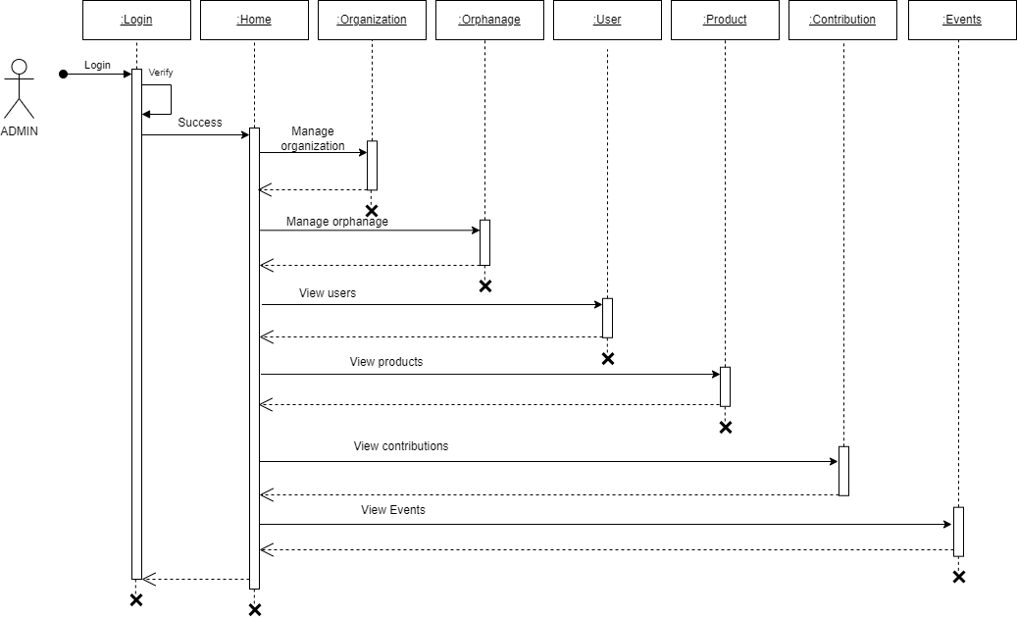

**2)**

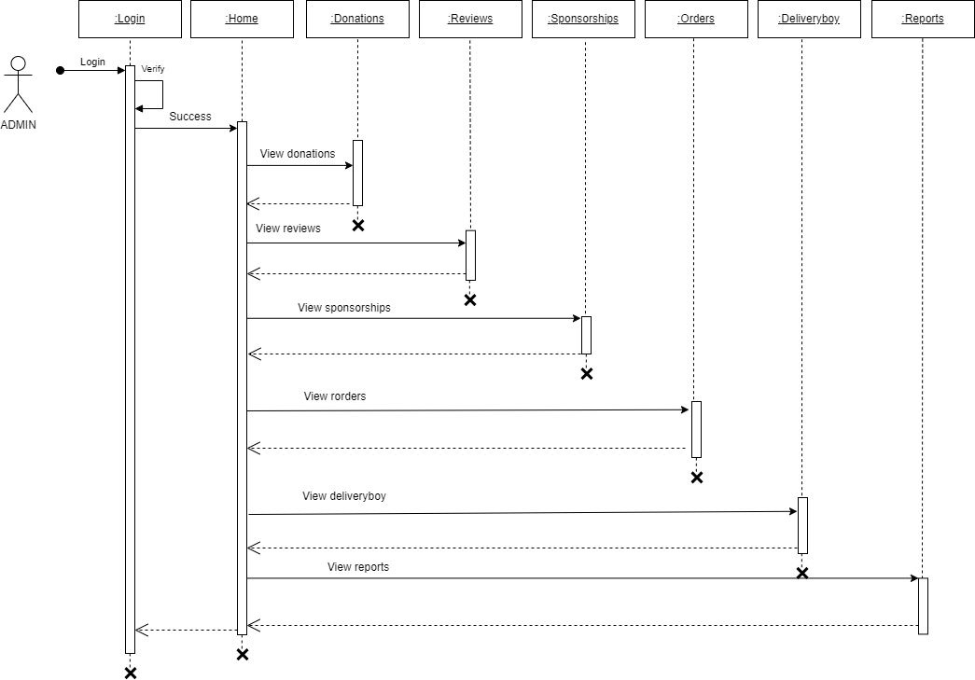

**Organization:**

**1)**

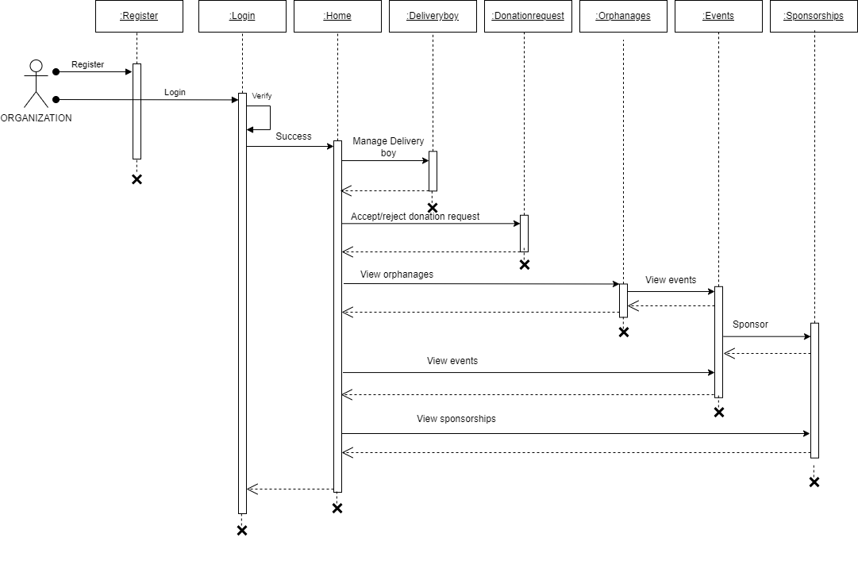

**2)**

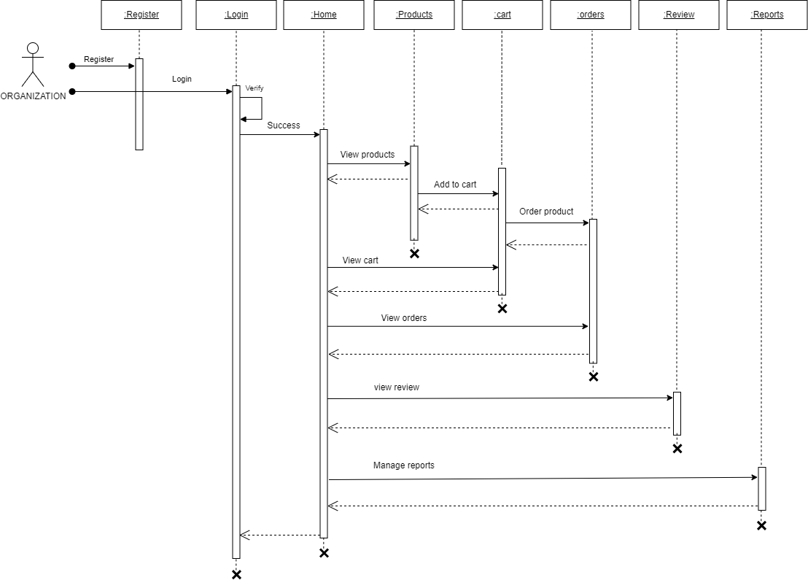

**Orphanage:**

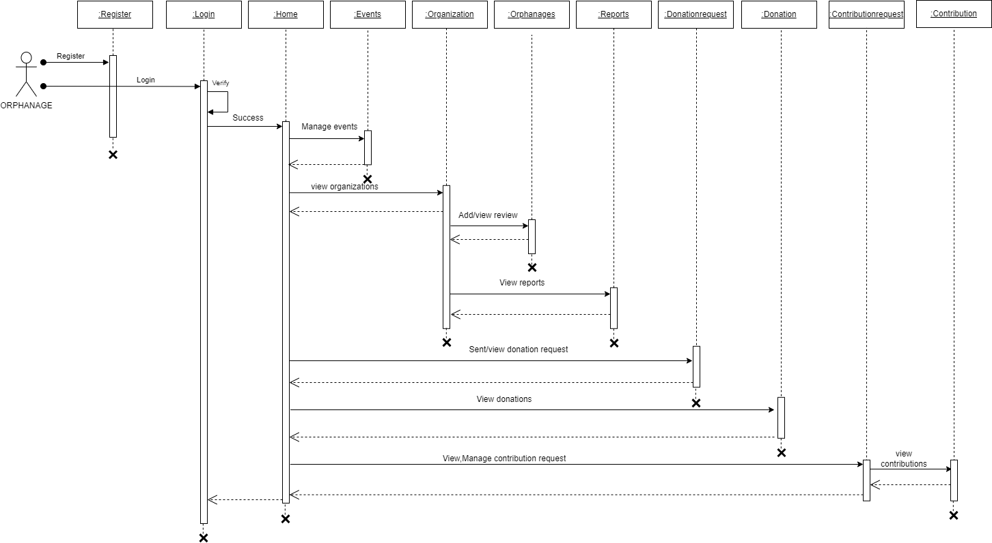

**User:**

**1)**

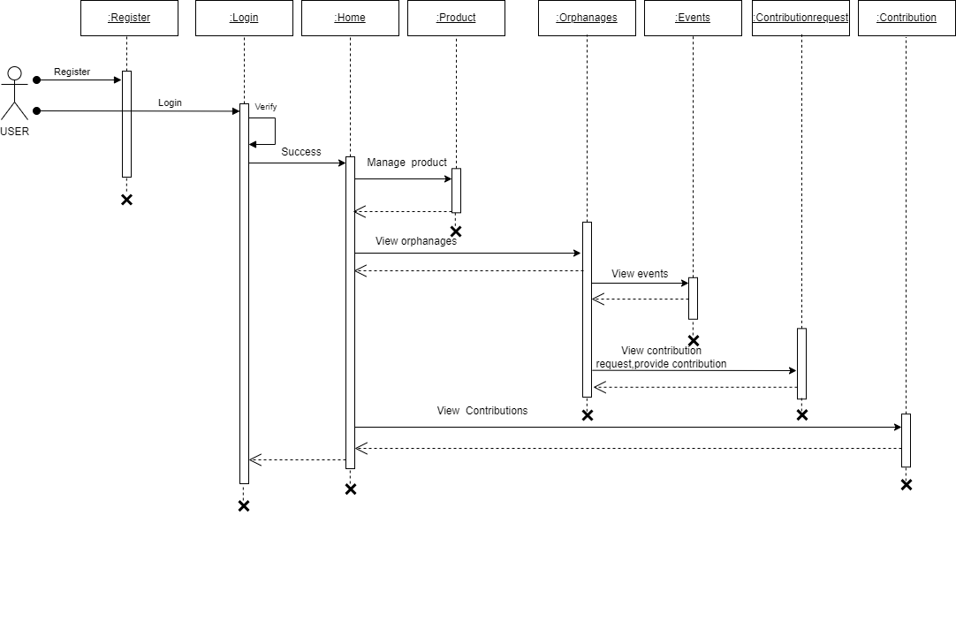

**2)**

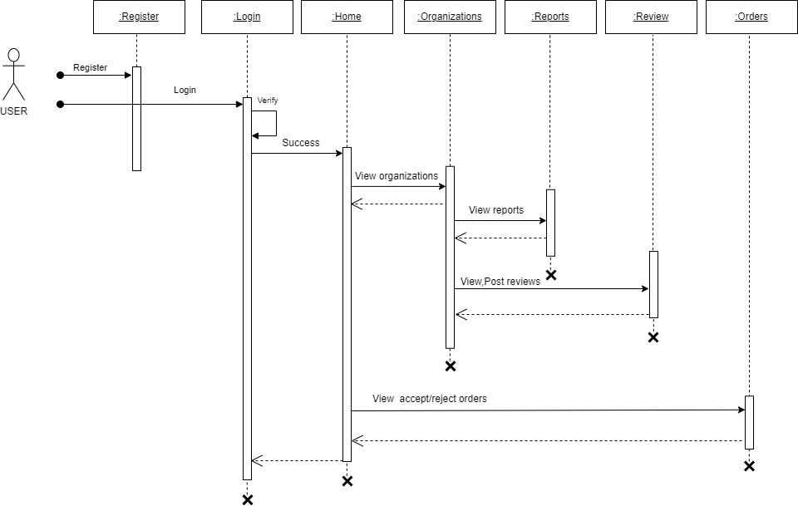

**Delivery boy**

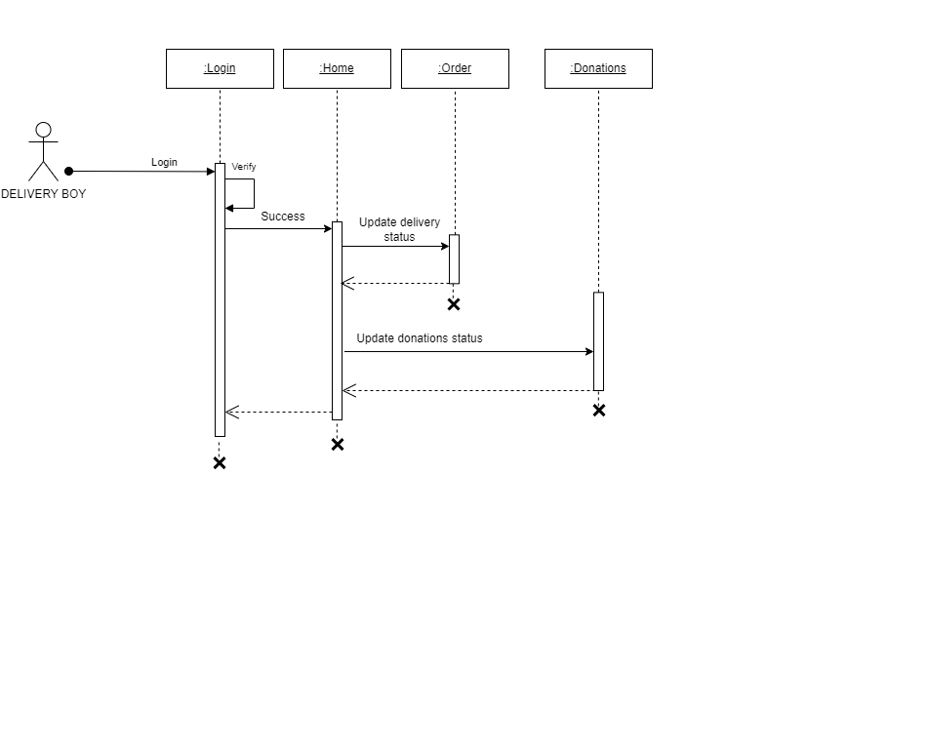

**SYSTEM DEVELOPMENT**

### SYSTEM DEVELOPMENT

System development is a series of operations to manipulate data to produce output from a computer system. The principal activities performed during the development phase can be divided into two major related sequences.

* External system development
* Internal system development

The major external system activities are:

* Implementation
* Planning
* Equipment acquisition
* Installation

##### Coding

The purpose of code is to facilitate the identification and retrieval of items of information. A code is an ordered collection of symbols designed to provide unique identification of an entity or an attribute. Code also shows interrelationship among different items. Codes are used to identify, access, sort, matching records. The code ensures that only one value of code with a single meaning is applied to give an entity or attribute as described in various ways.

### Node JS

##### Node js is an open-source, cross-platform JavaScript runtime environment that enables developers to build scalable and high-performance applications. It is built on top of the V8 JavaScript engine used by Google Chrome and provides an event-driven, non-blocking I/O model that makes it well-suited for real-time web applications. Node.js enables developers to write server-side applications using JavaScript, which is a popular and widely-used programming language on the web. It has a vast ecosystem of third-party packages and libraries that can be easily installed using the Node Package Manager (NPM). Node js applications can be run on various platforms such as Windows, Mac, and Linux.

##### Express JS

Express.js is a minimal and flexible Node.js web application framework that provides a set of robust features for building web and mobile applications. It is one of the most popular and widely-used frameworks for Node.js, and is known for its simplicity and ease of use. Express.js provides a set of features for developing serverside web applications, including routing, middleware support, template engines, and much more. It also provides an easy-to-use API for interacting with databases such as MongoDB and MySQL, and supports a variety of templating engines, such as Pug, Handlebars, and EJS.

**Mongo DB**

MongoDB is a popular document-oriented NoSQL database system that allows developers to store and manage large amounts of data in a flexible and scalable way. It is an open-source database that uses JSON-like documents with optional schemas, which makes it easy to work with and suitable for a variety of use cases. One of the key benefits of MongoDB is its ability to scale horizontally. This means that developers can add new servers to their database cluster as the amount of data or traffic increases, which allows the database to handle more requests and ensures that it can continue to perform well even as the application grows.

## SYSTEM TESTING AND IMPLEMENTATION

### SYSTEM TESTING AND IMPLEMENTATION

Testing is the vital to the success of the system. It makes a logical assumption that if all the parts of the system are correct, the goal will be successfully achieved in this project. It is the stage of implementation, which ensures that system works accurately and effectively before the live operation commences.

#### Types of Testing

##### Unit testing

Unit testing is a software testing technique that focuses on testing

individual units or components of a software system in isolation. The purpose of unit testing is to ensure that each unit functions correctly and produces the expected outputs when provided with specific inputs.

##### Black box testing

Black box testing is a software testing technique where the tester examines and tests the software without having knowledge of its internal structure, implementation details, or code.

##### White box testing

White box testing is a software testing technique that focuses on examining and validating the internal structure, design, and code of the software. Testers have access to the internal components, implementation details, and source code, allowing them to assess the internal logic and behavior of the software.

#### Implementation

Implementation is the stage of project, when theoretical design is turned in to a working system. The most crucial stage is achieving a successful system and confidence that the new system will be work effectively. It involves careful planning, investigation of the manual system and to new system. Implementation means converting a new or revised system design into an operational one. The implementation includes all those activities that take place to convert from the old system to the new one.

## SYSTEM MAINTENANCE

### SYSTEM MAINTENANCE

Maintenance is making adaptation of the software for external changes (requirements changes or enhancements) and internal changes (fixing bugs). When changes are made during the maintenance phase all preceding steps of the model must be revisited.

There are 3 types of maintenance:

* Corrective (Fixing bugs/errors)
* Adaptive (Updates due to environment changes)
* Perfective (Enhancements, requirements changes)

Maintenance is enigma of the system development. The definition of the software maintenance can be given describing four activities that are undertaken after the program is released for use. The maintenance activity occurs since it is unreasonable to assume that software testing will uncover all in a large system. The second activity that contributes the definition of maintenance occurs since rapid changes are encountered in every aspect of computing. The third activity involves recommendation for new capabilities, modification to the existing functions and general enhancements when the software is used. The fourth maintenance activity occurs when software is changed to improve future maintainability or reliability.

## FUTURE ENHANCEMENT

### FUTURE ENHANCEMENT

The proposed system currently serving Kerala, envisions expanding its geographical reach to new states. By providing a broader area, Care Connect seeks to connect with more orphanages, organizations and users. The development of a dedicated mobile application will enhance accessibility, providing users with a seamless on-the-go experience. Implementation of a real-time tracking feature for donated items will be introduced. This feature would allow users, charitable organizations, and orphanages to track the status and location of donated items from the moment they are picked up by the delivery boy until they reach their final destination at the orphanage. Another potential enhancement will be the implementation of a feedback and rating system for delivery boys. This feature would allow users, charitable organizations, and orphanages to provide feedback and rate the performance of delivery boys based on their professionalism, timeliness, and quality of service.

## CONCLUSION

### CONCLUSION

The project entitles “Care Connect” marks a significant step forward in revolutionizing the donation process. Going beyond the conventional methods, this digital platform embraces a user-friendly interface, expanding the connections between orphanages , organizations and users. By addressing the challenges encountered by both charitable organizations and users, this platform streamlines operations and fosters greater collaboration within communities. Through its user-friendly interface and transparent communication channels, Care Connect not only enhances efficiency and effectiveness but also promotes a sense of unity and shared responsibility.

By making it easy for people to connect and helping them contribute in a meaningful way, Care Connect shows the kindness and care we have for others and brings people together to make a positive impact on the lives of those in need.

## APPENDIX

**12.APPENDIX**

**Landing page**

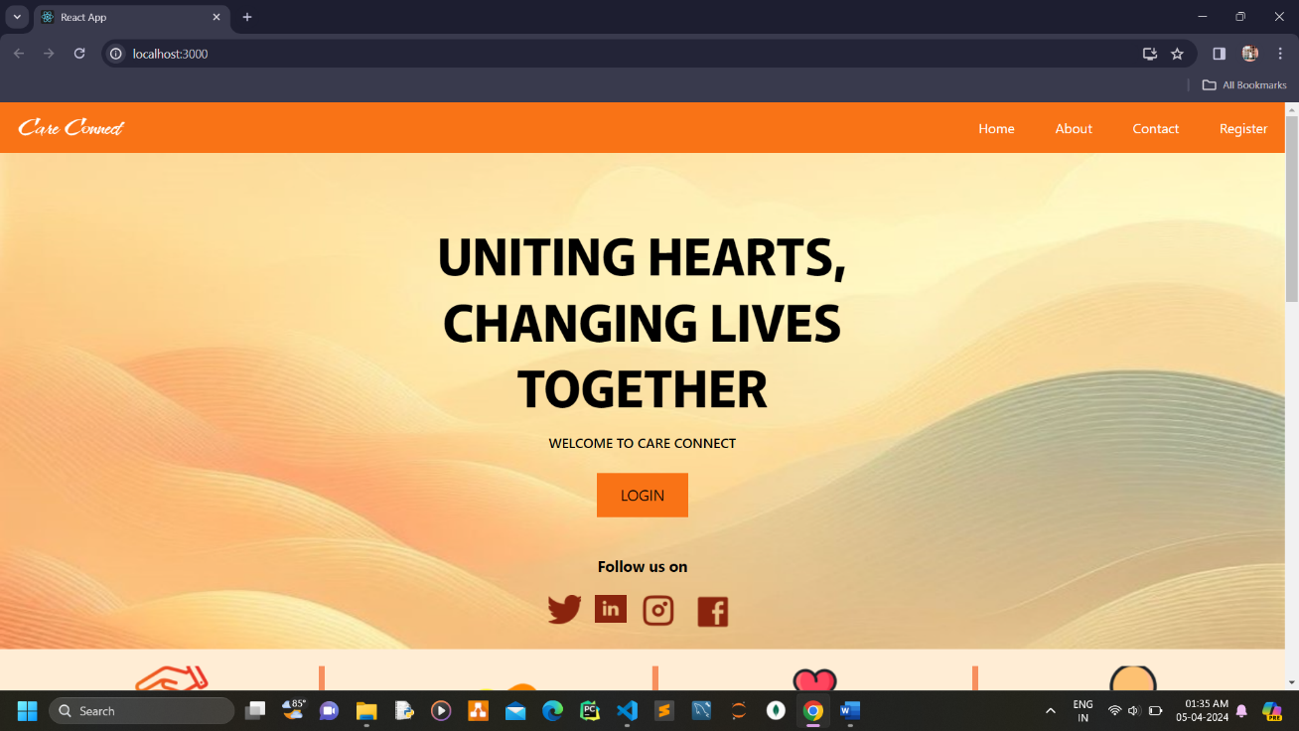

**Login page**

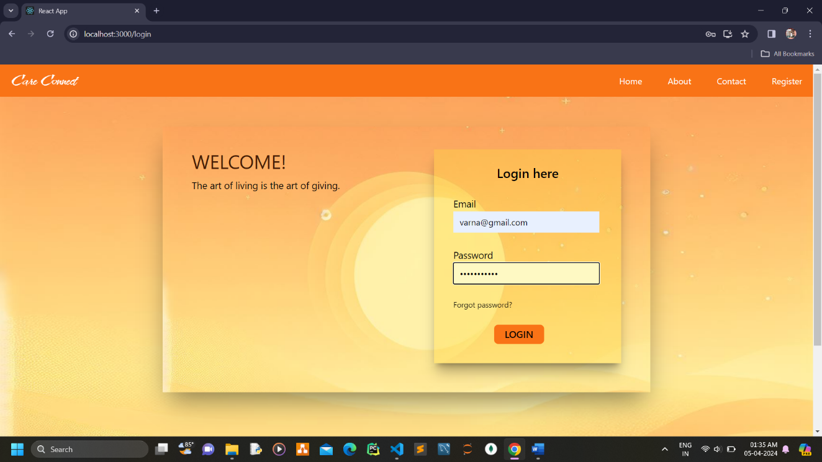

**User registration**

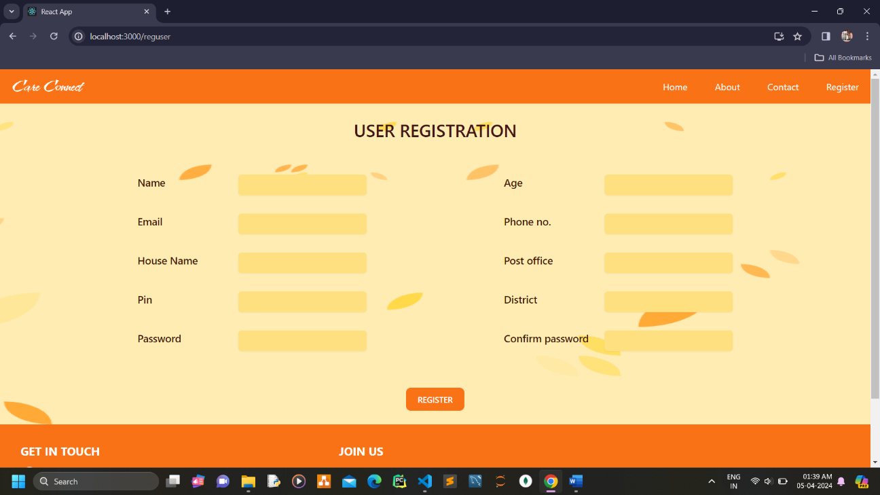

**Orphanage registration**

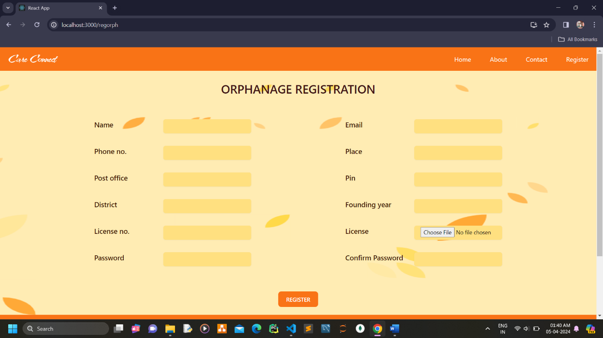

**Organization registration**

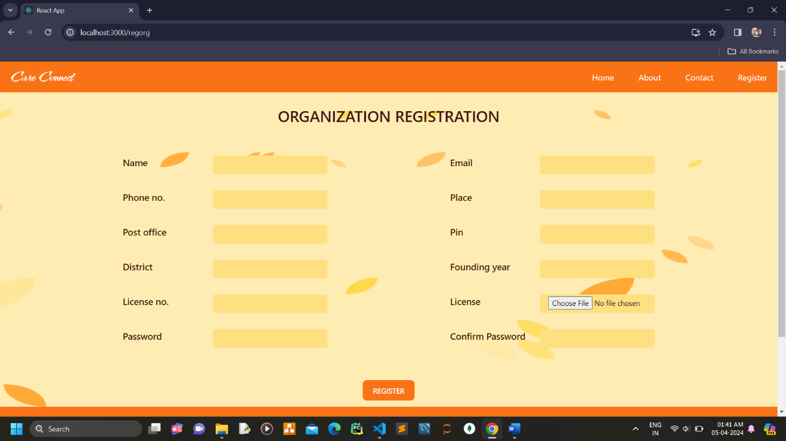

**Admin home page**

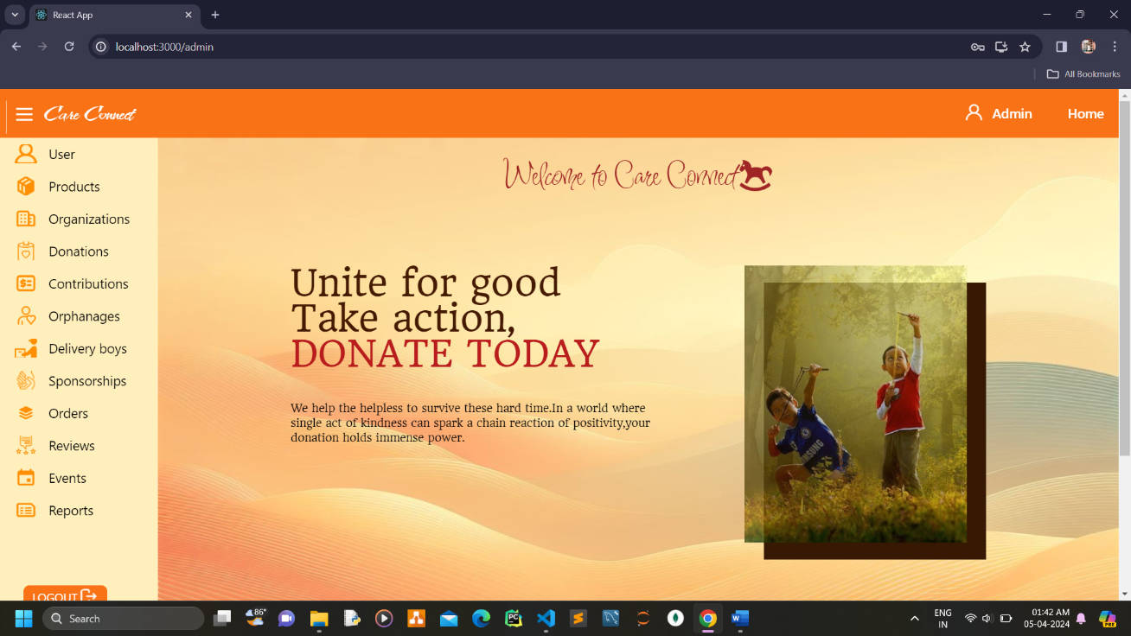

**Admin view users**

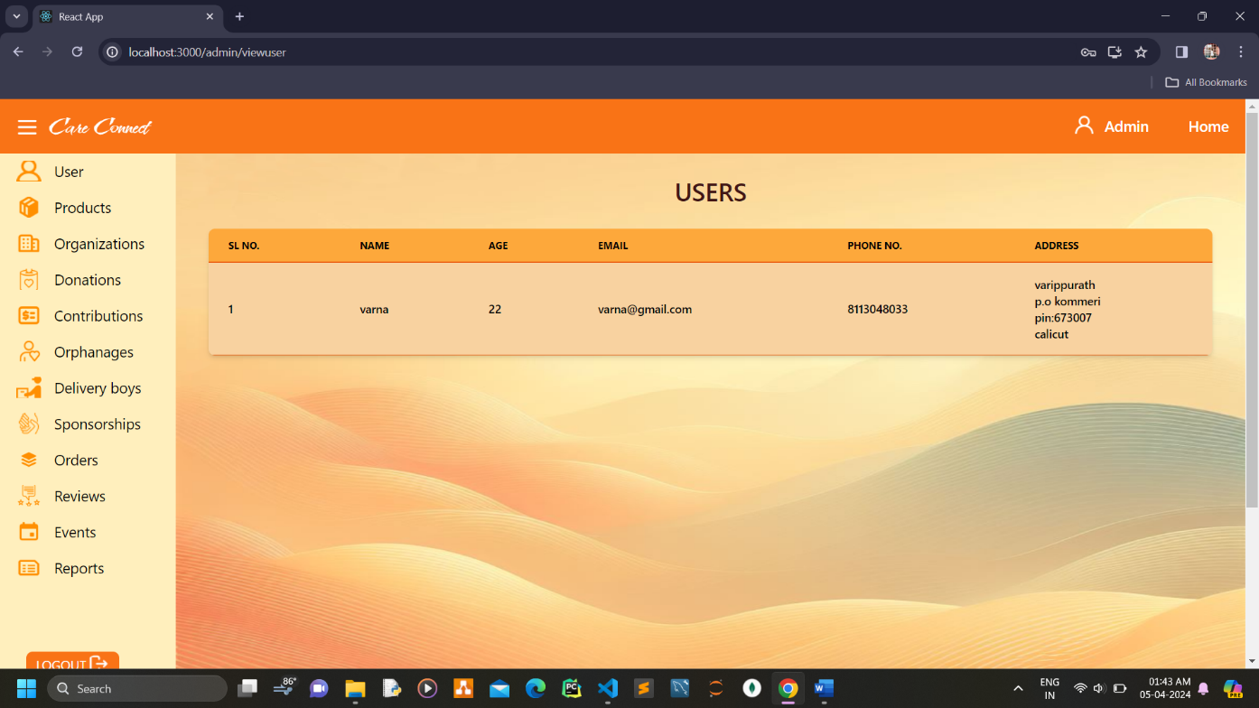

**Admin view products**

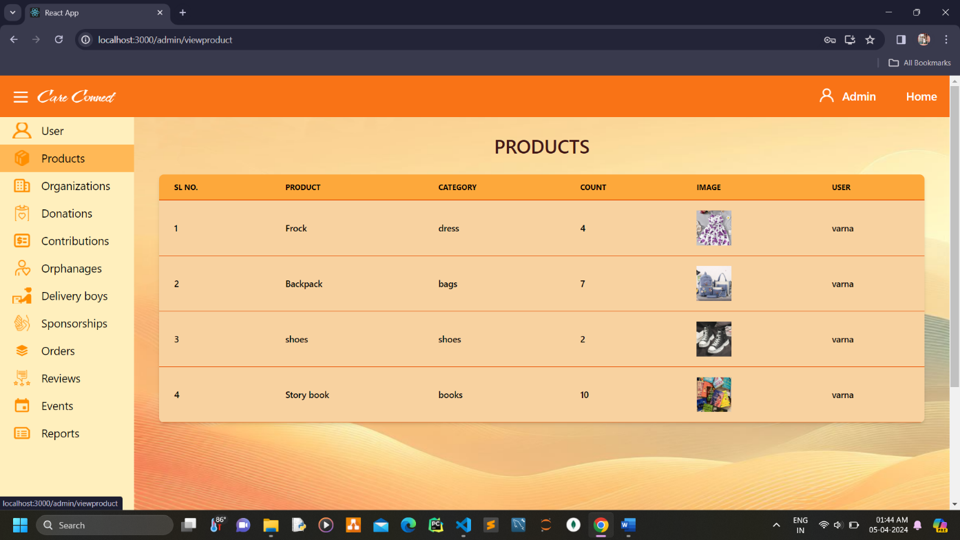

**Admin view organizations**

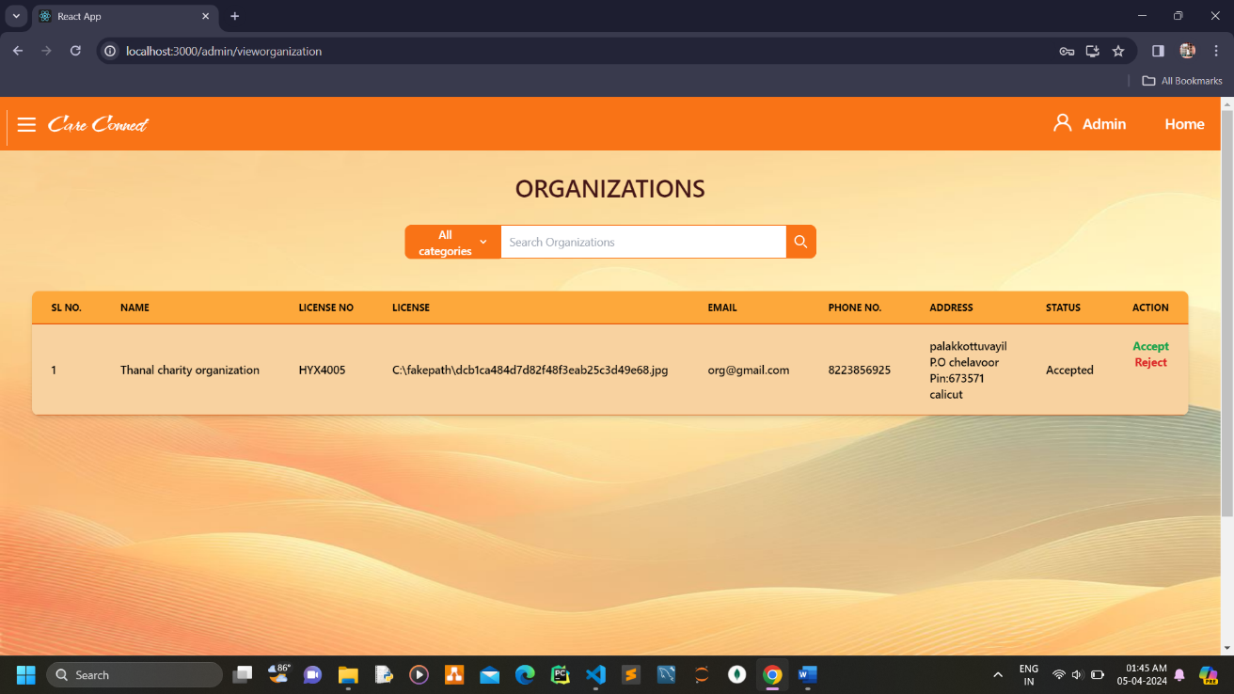

**Admin view donations**

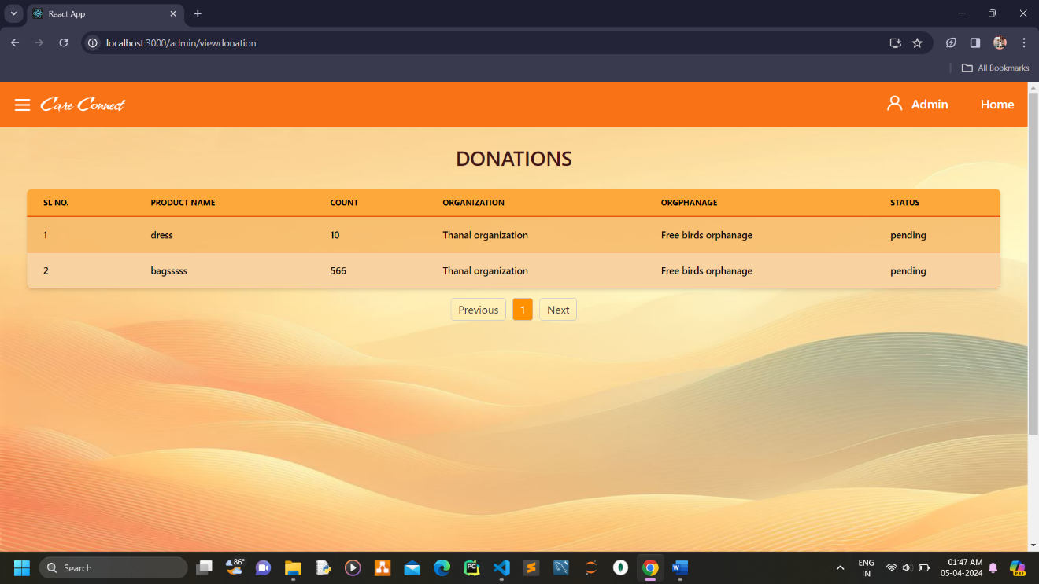

**Admin view contribution request**

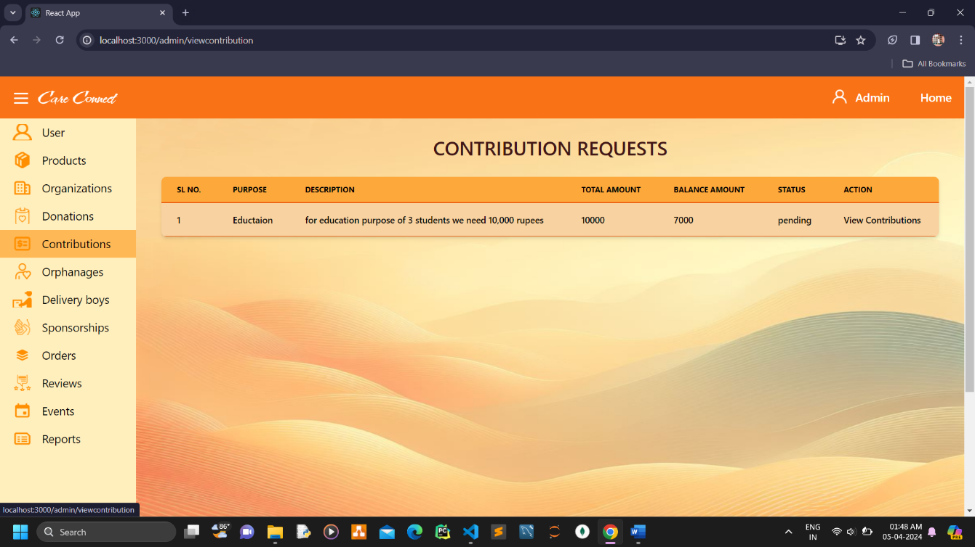

**Admin view contributions**

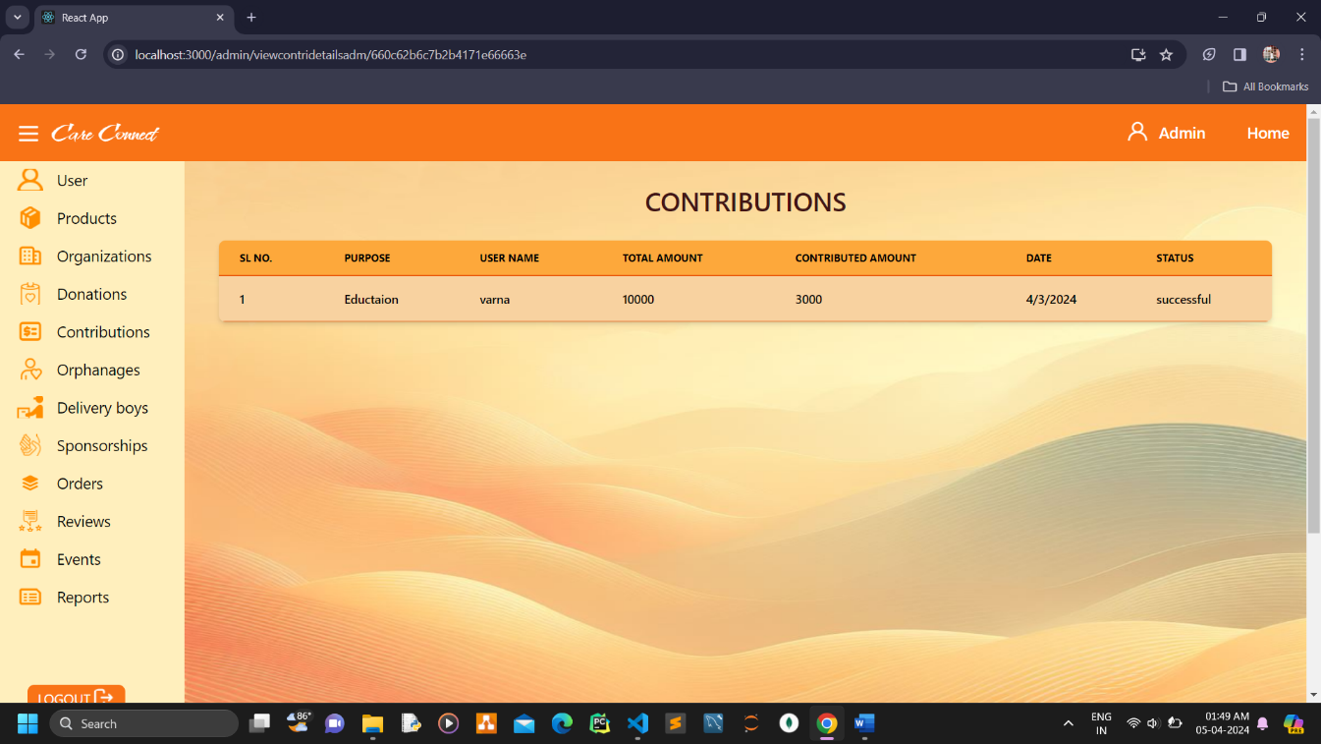

**Admin view orphanages**

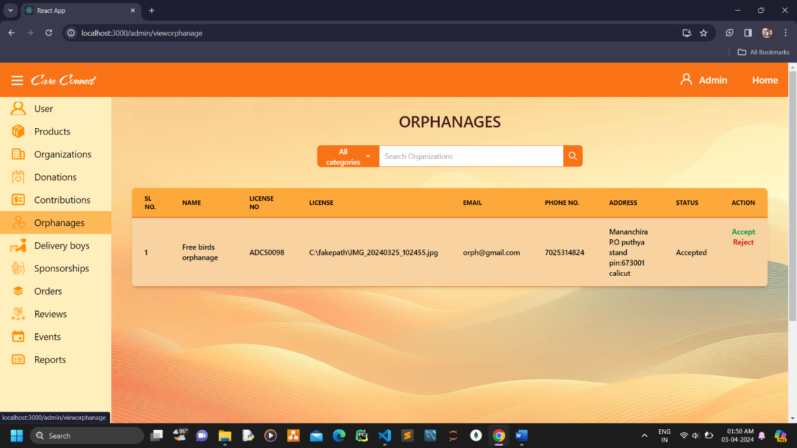

**Admin view delivery boys**

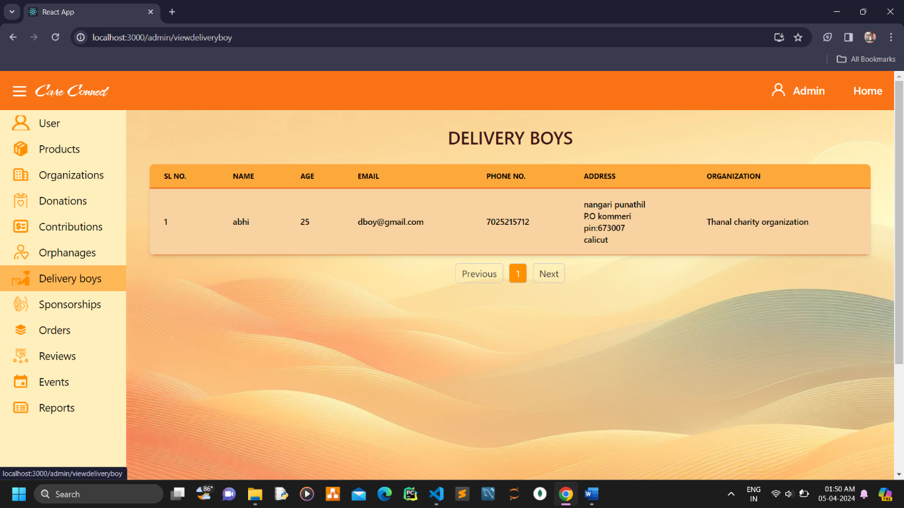

**Admin view sponsorships**

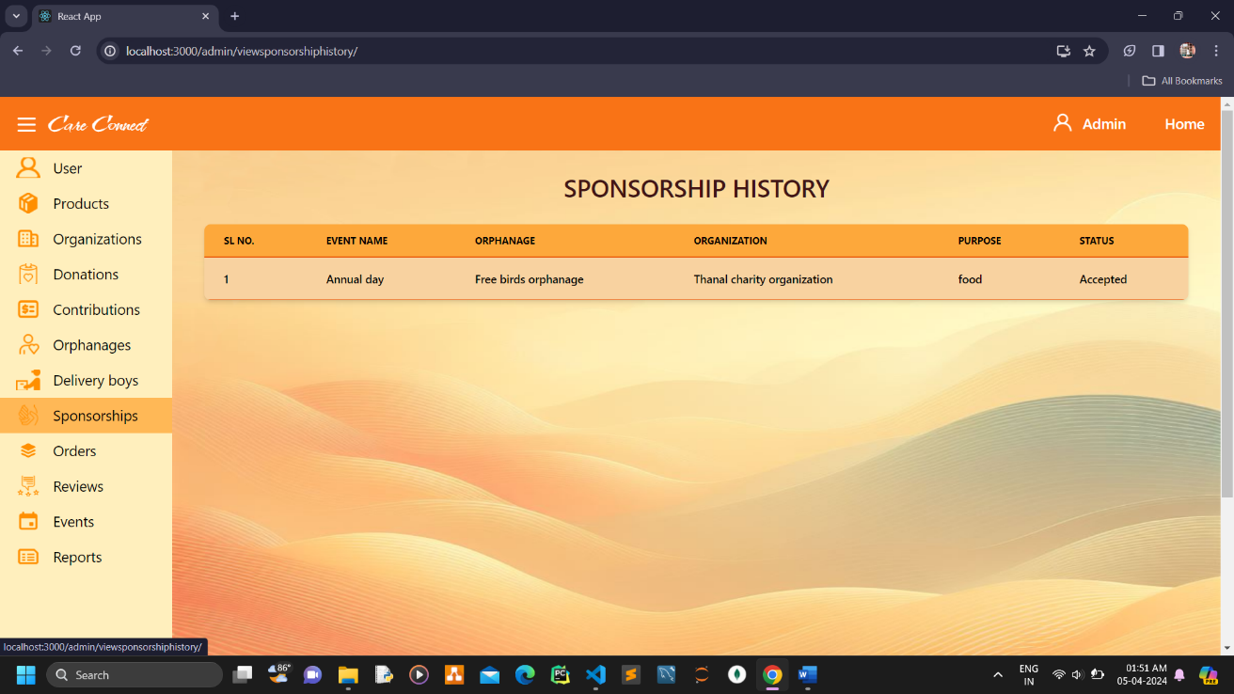

**Admin view orders**

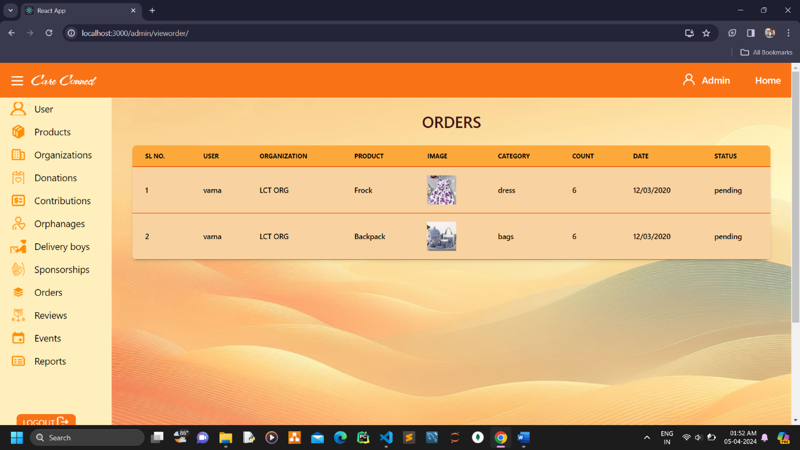

**Admin view events**

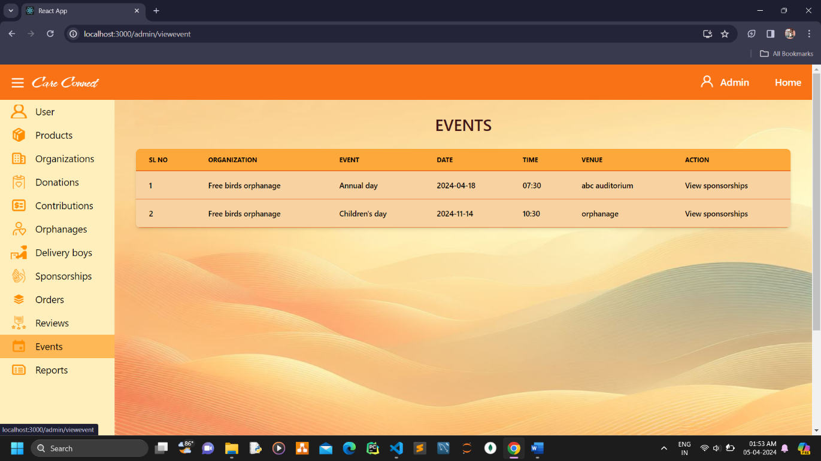

**Organization view and edit profile**

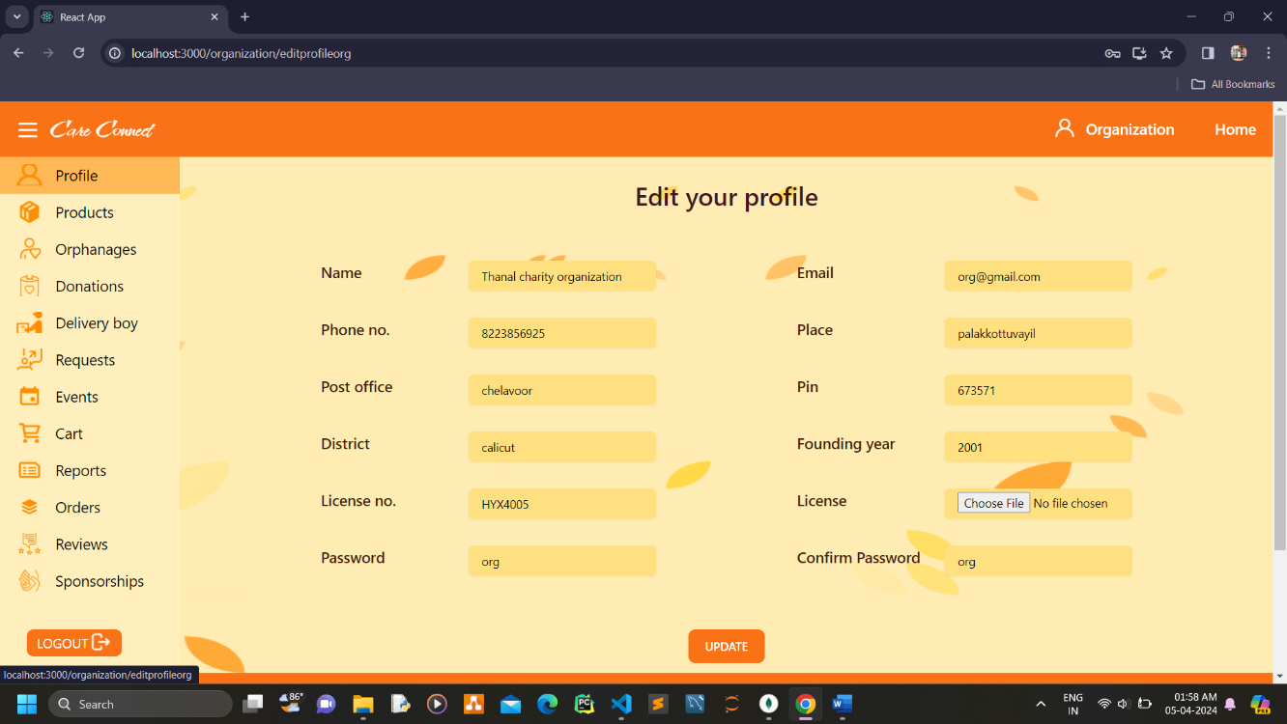

**Organization view products**

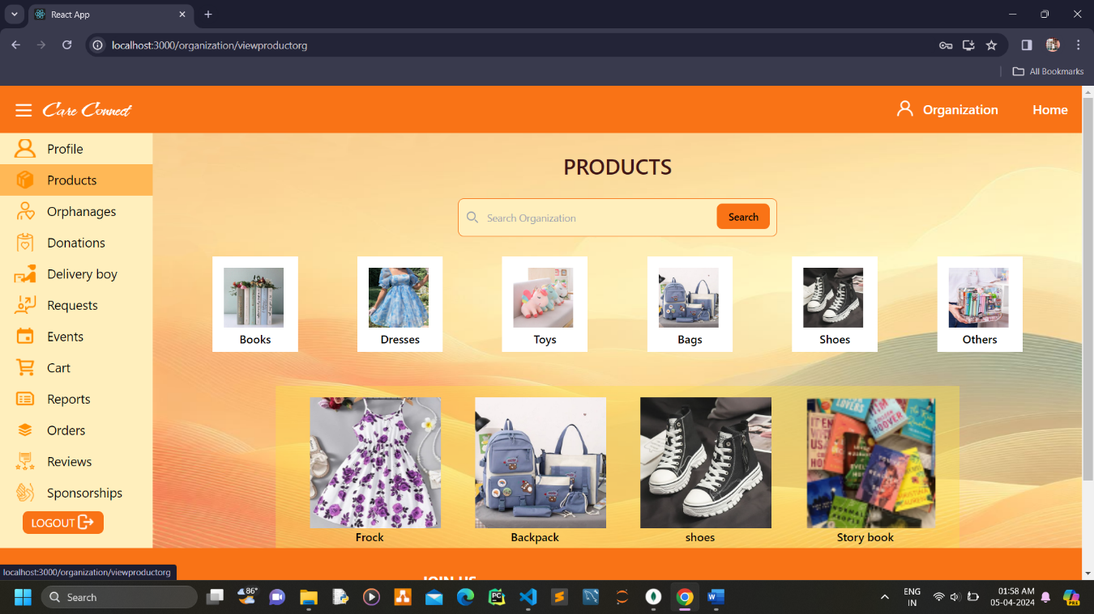

**Organization view product details**

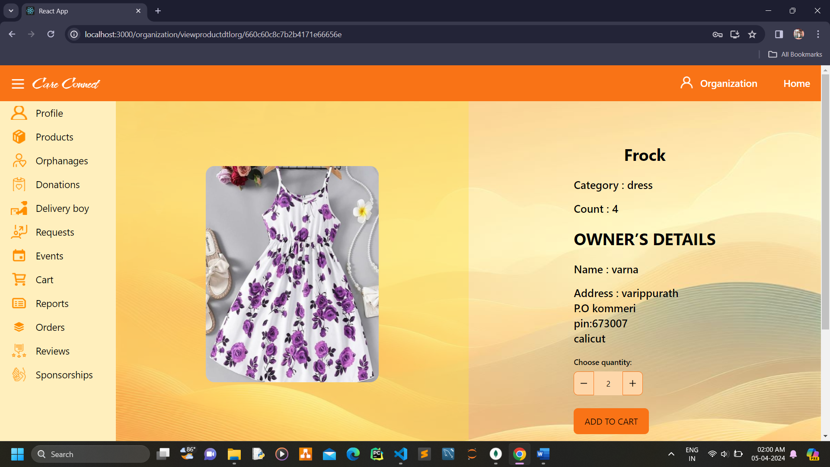

**Organization view orphanage**

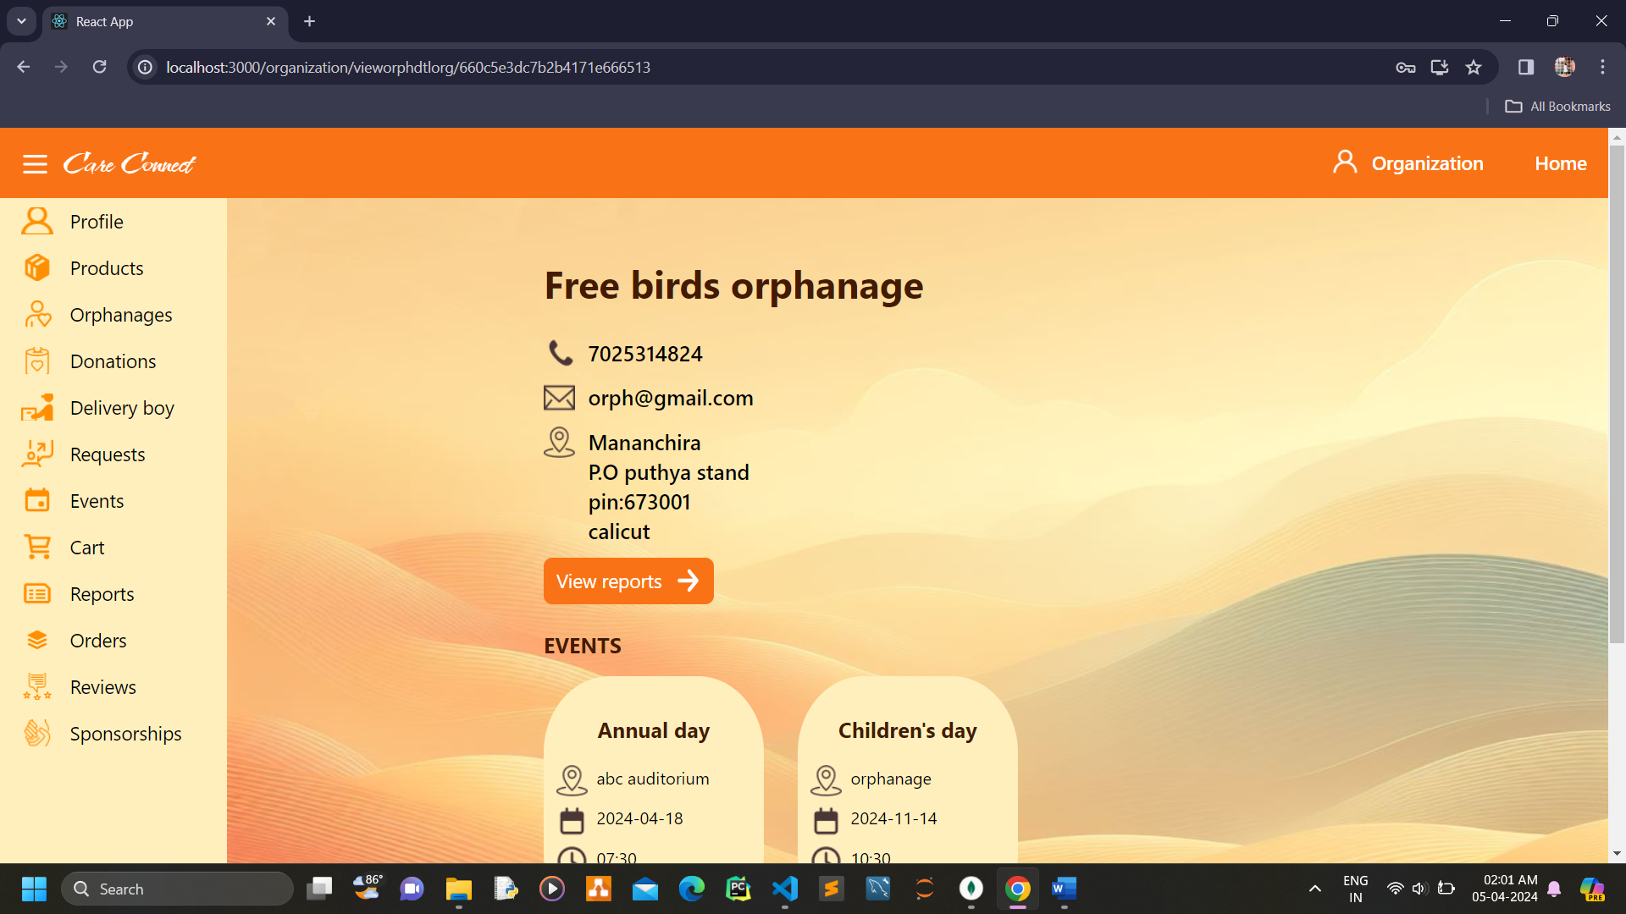

**Organization view delivery boys**

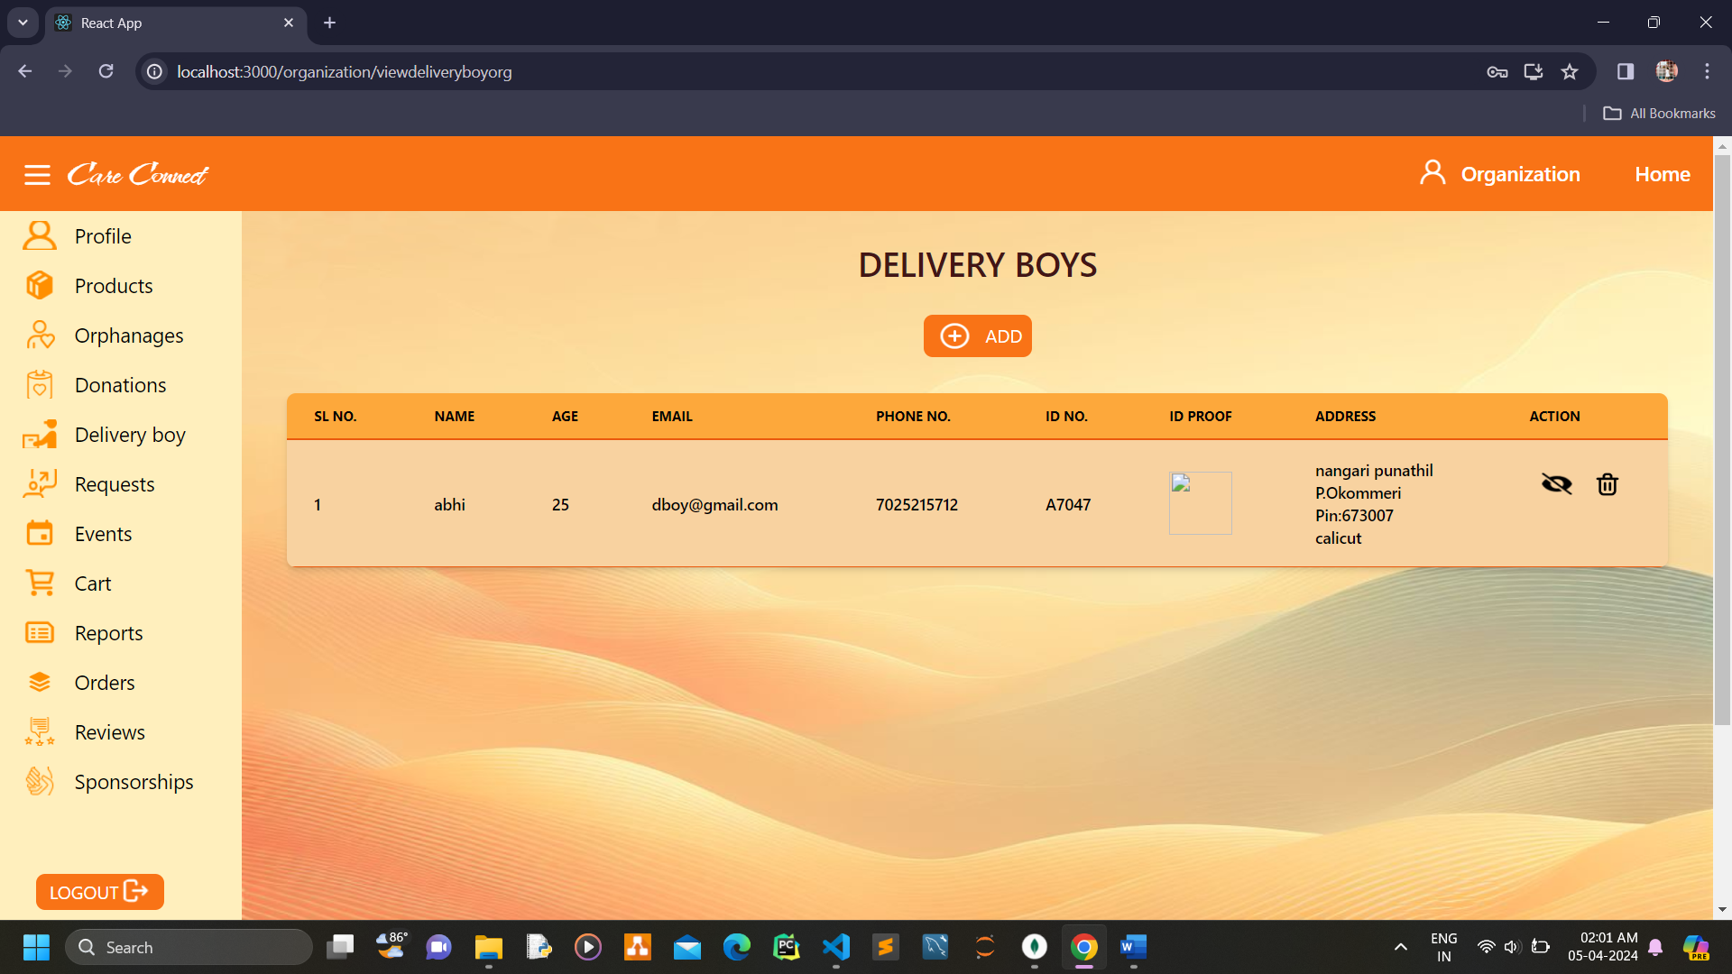

**Organization add delivery boys**

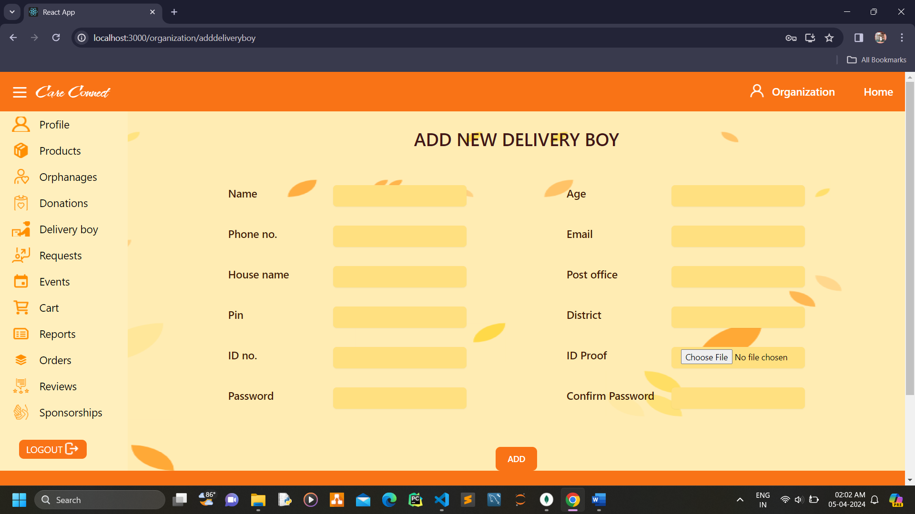

**Organization view donation requests**

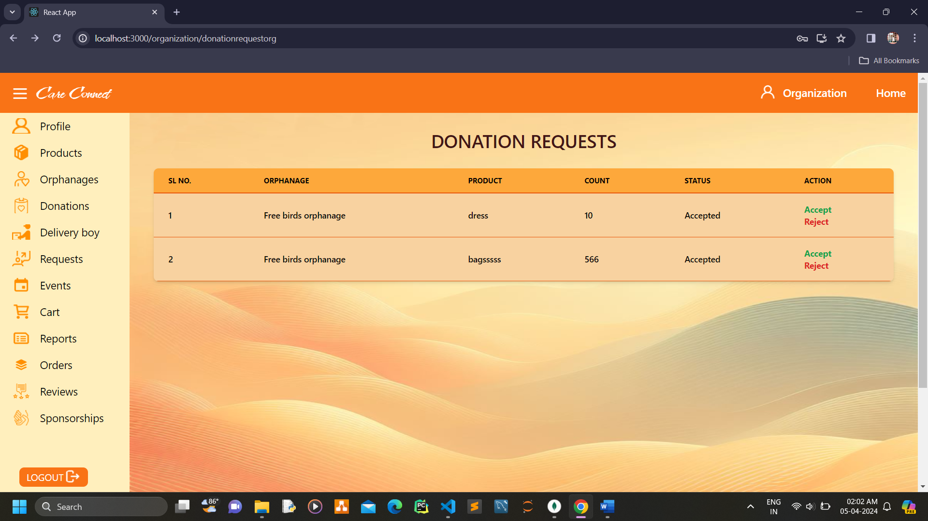

**Organization view events**

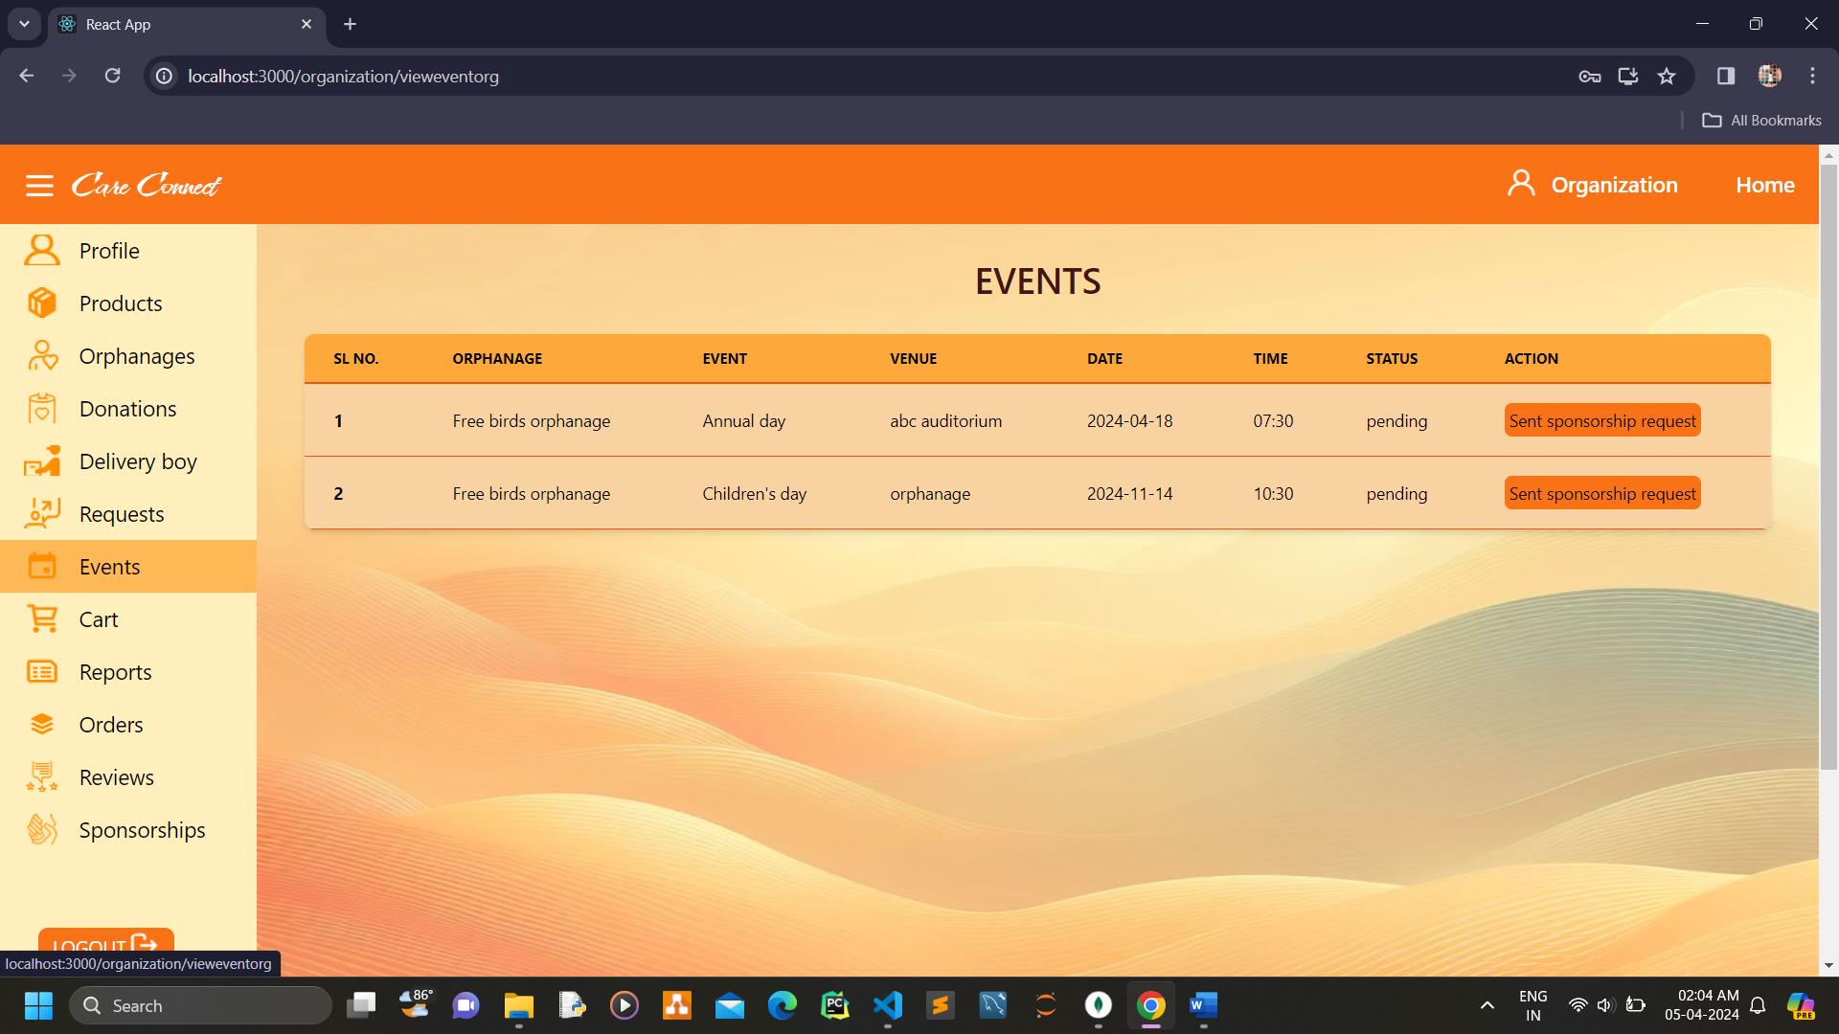

**Organization send sponsorship requests**

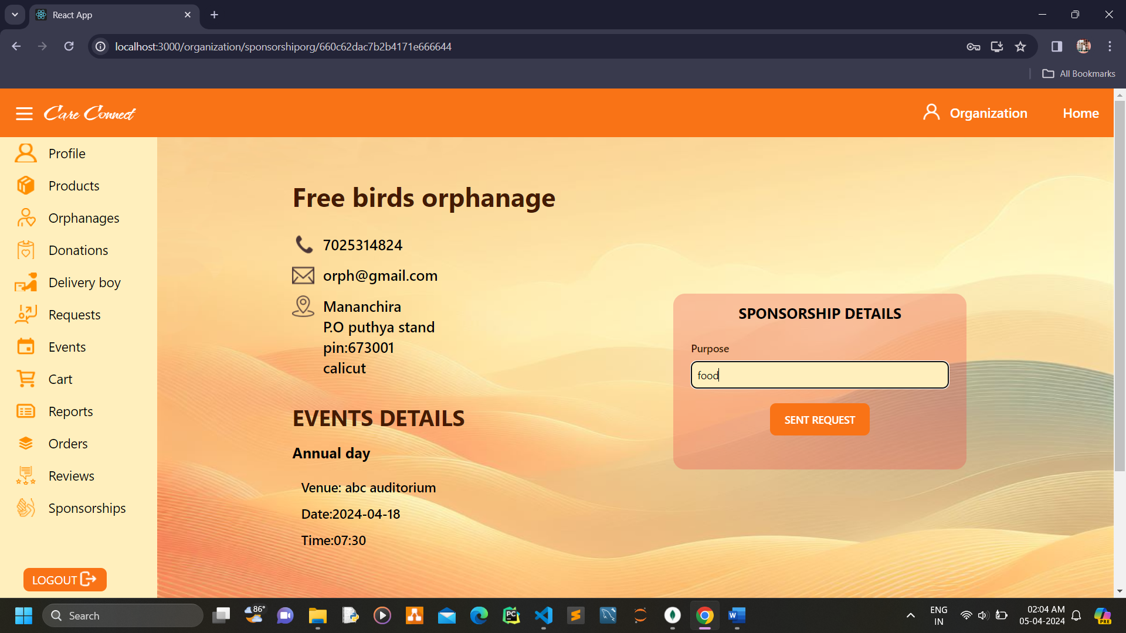

**Organization view cart**

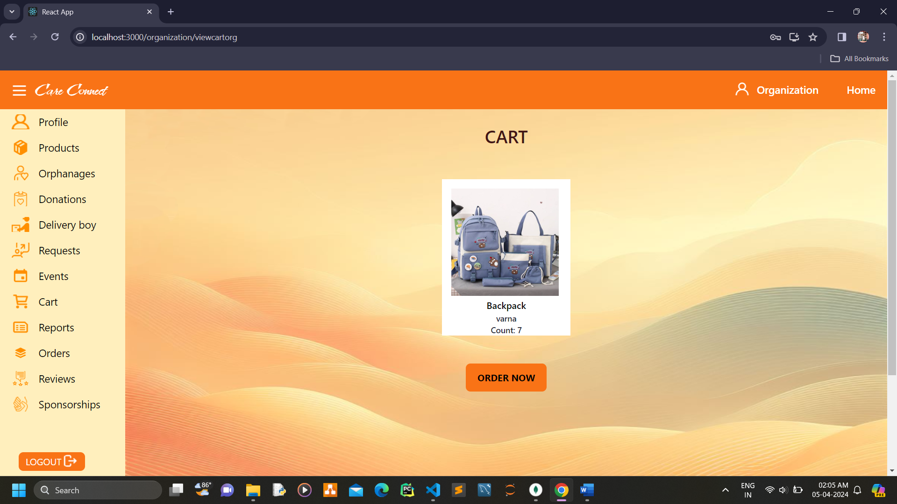

**Organization view report**

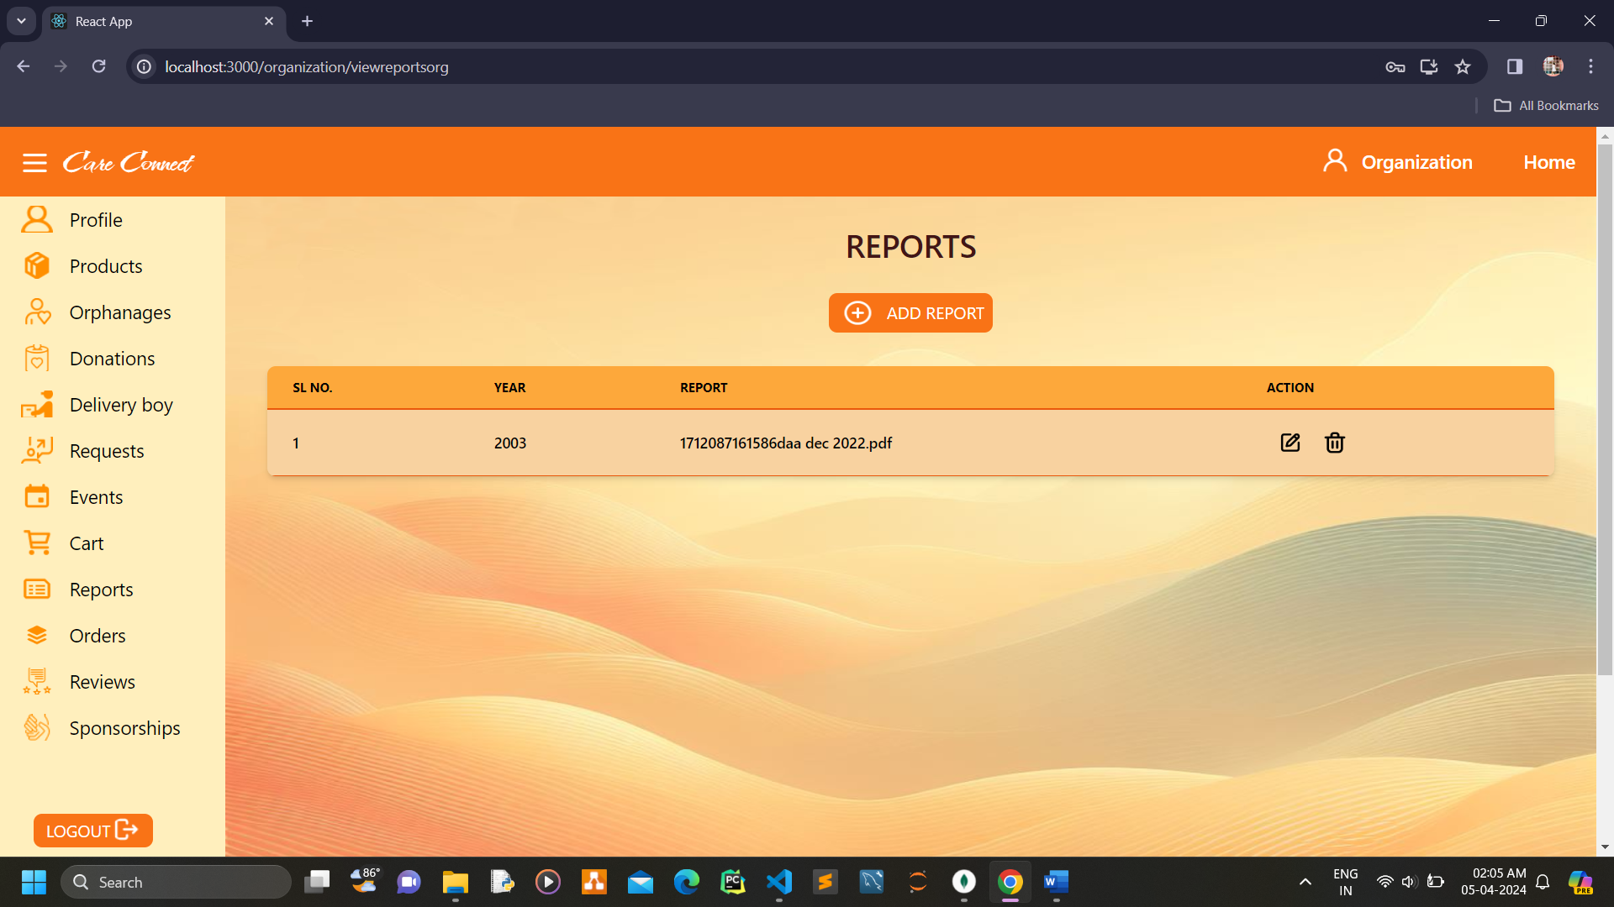

**Organization add reports**

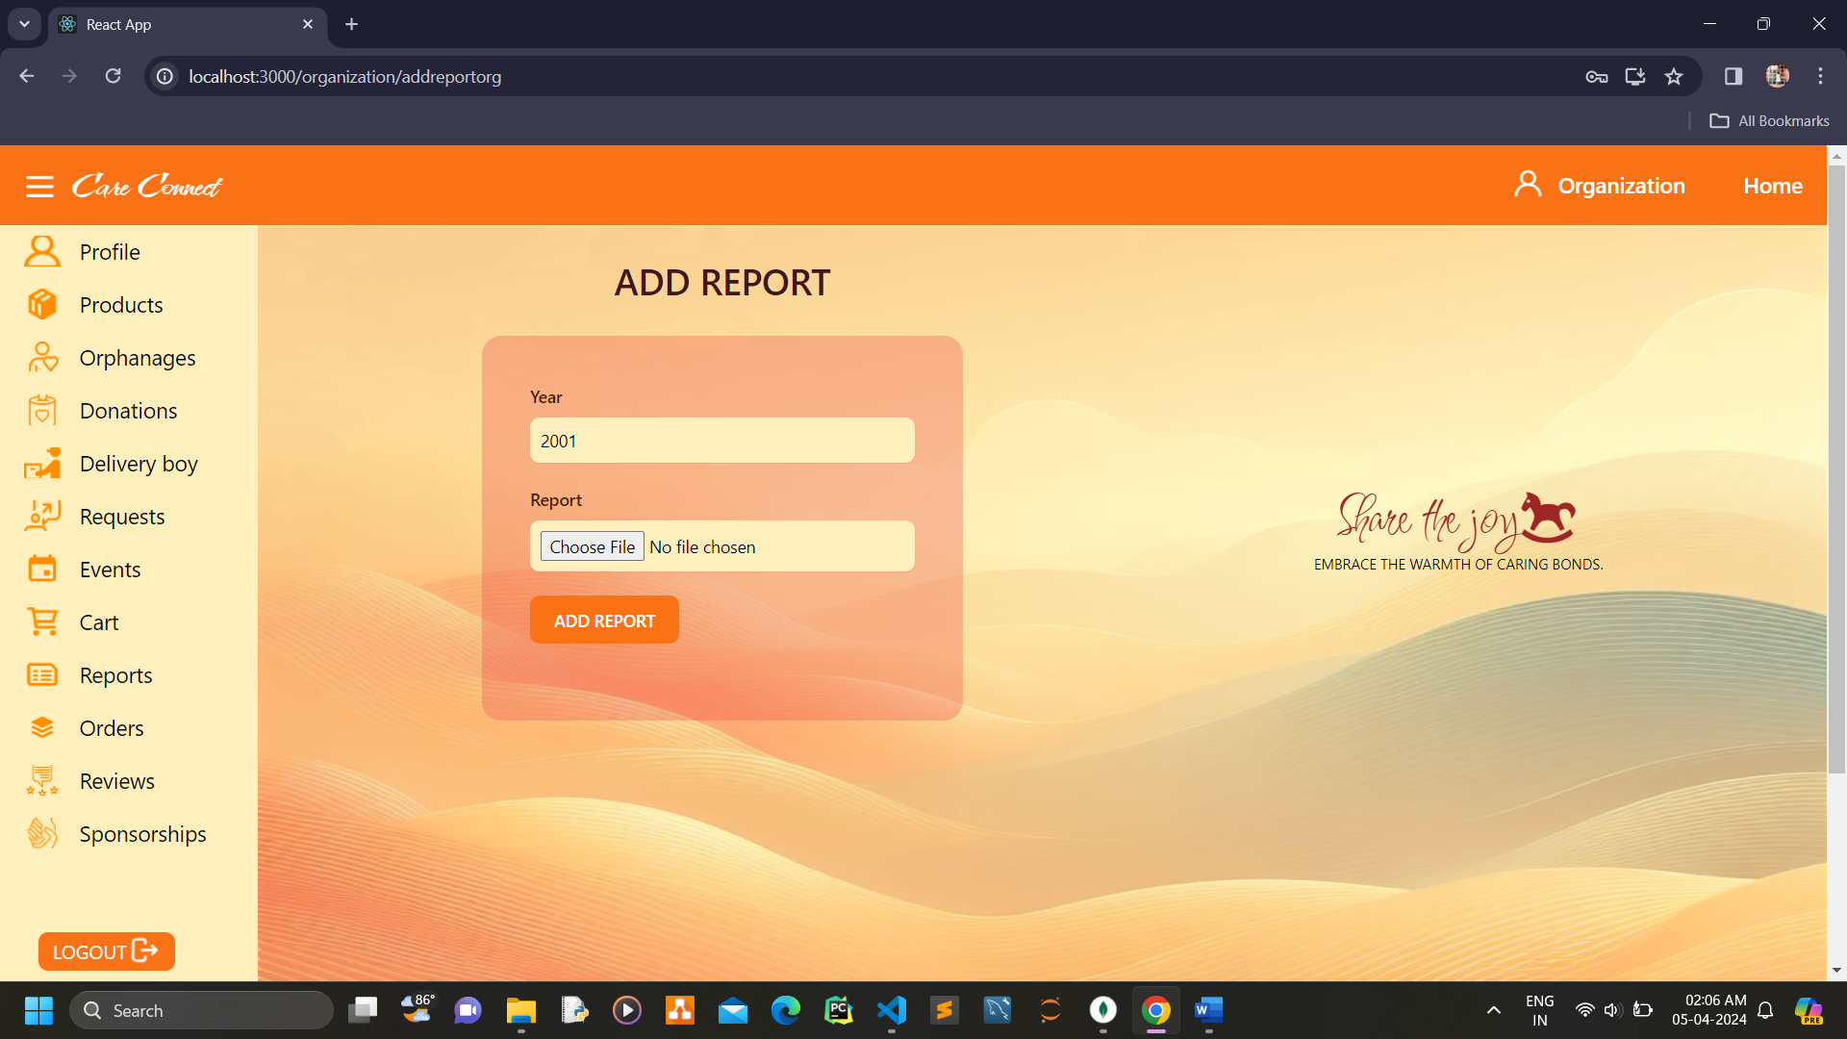

**Organization edit reports**

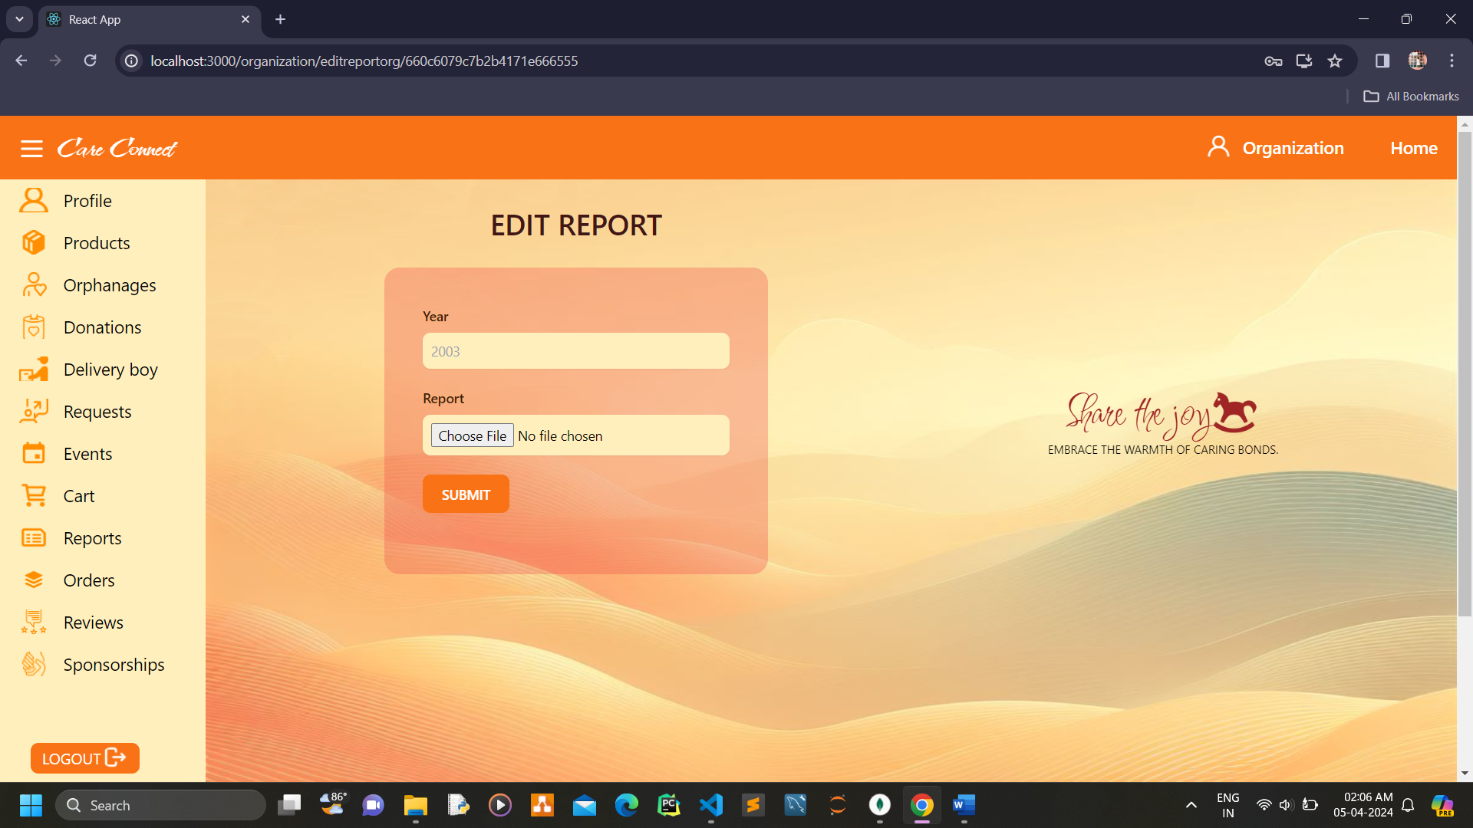

**Organization view orders**

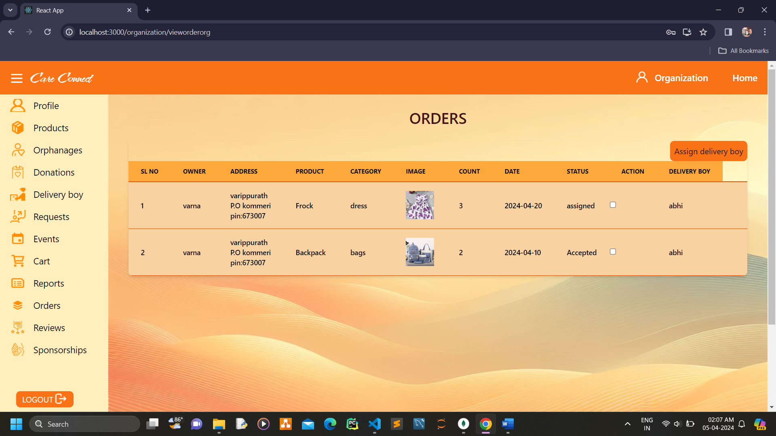

**Organization view reviews**

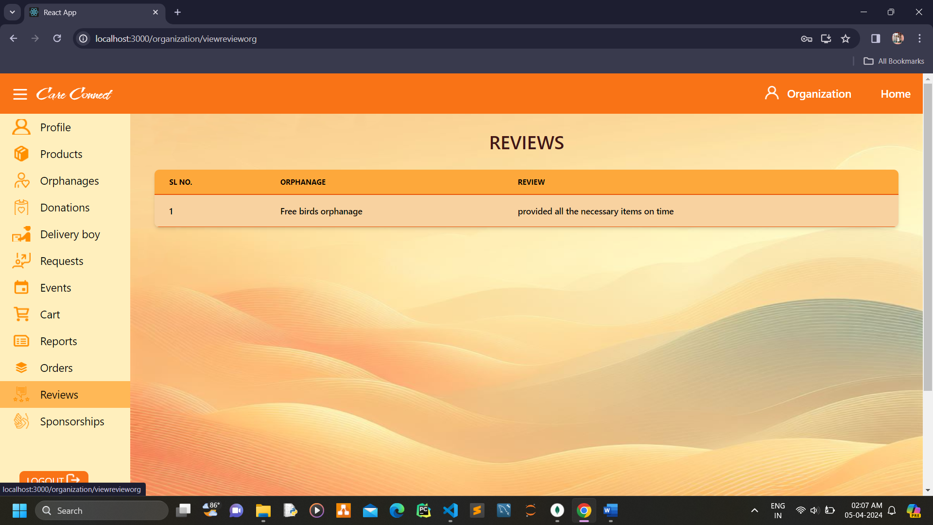

**Organization view sponsorships**

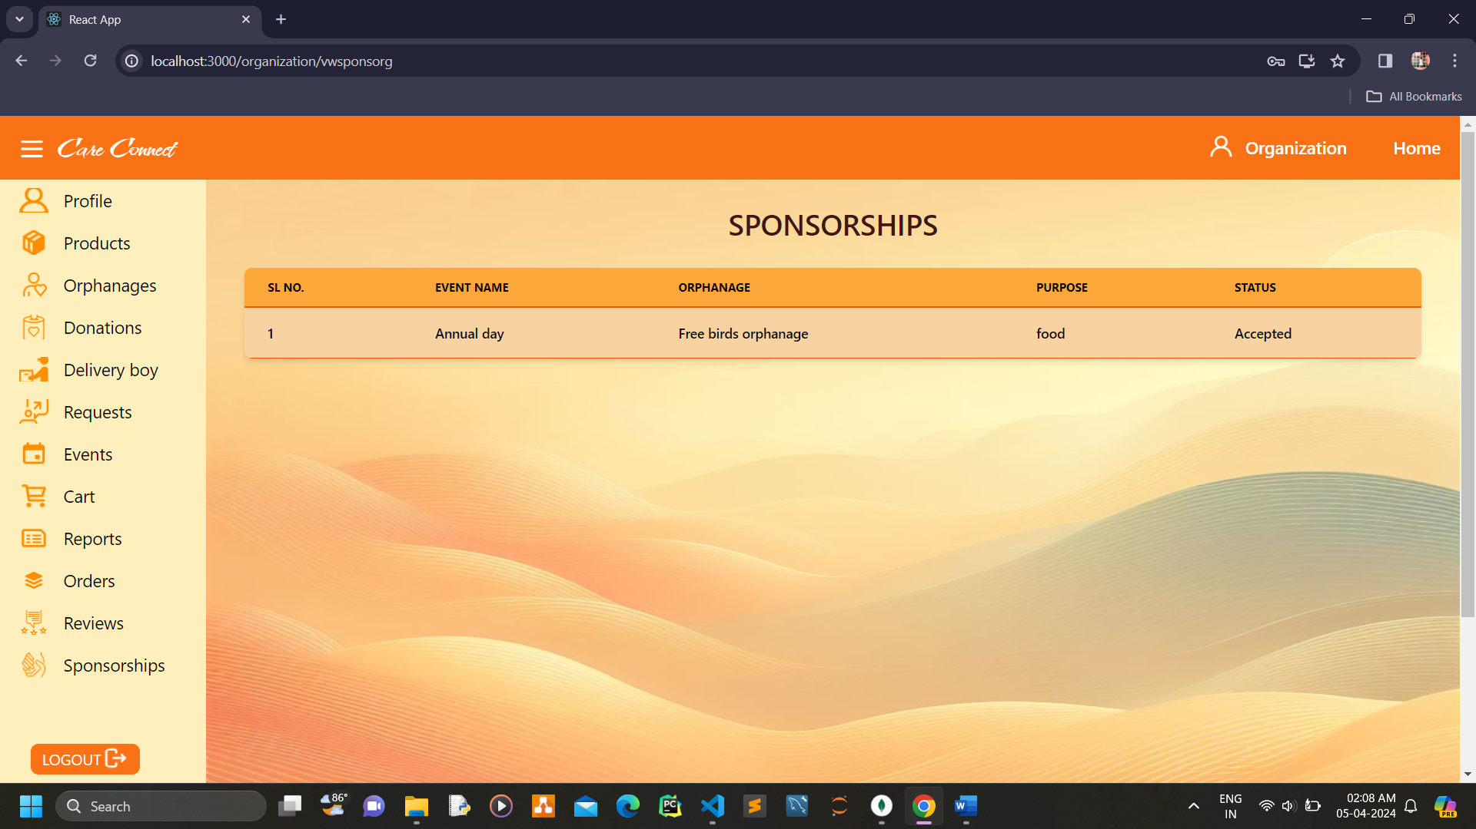

**Orphanage view and edit profile**

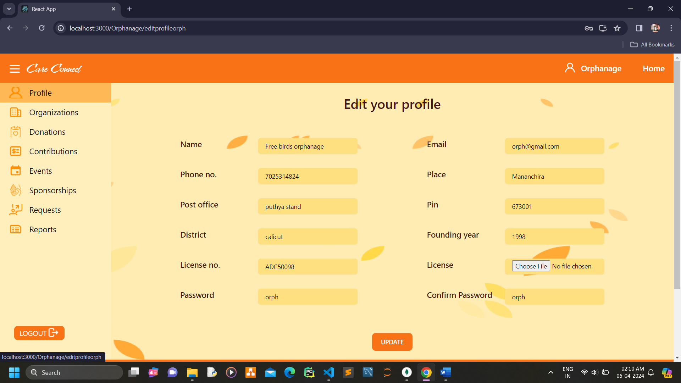

**Orphanage view organization**

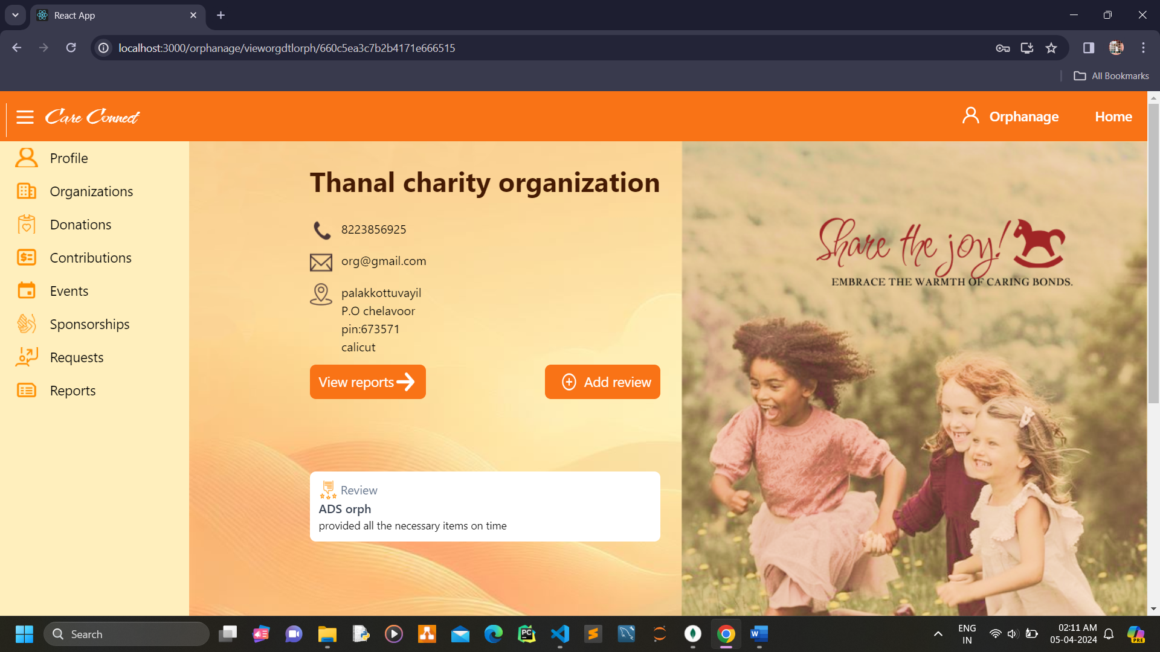

**Orphanage add review**

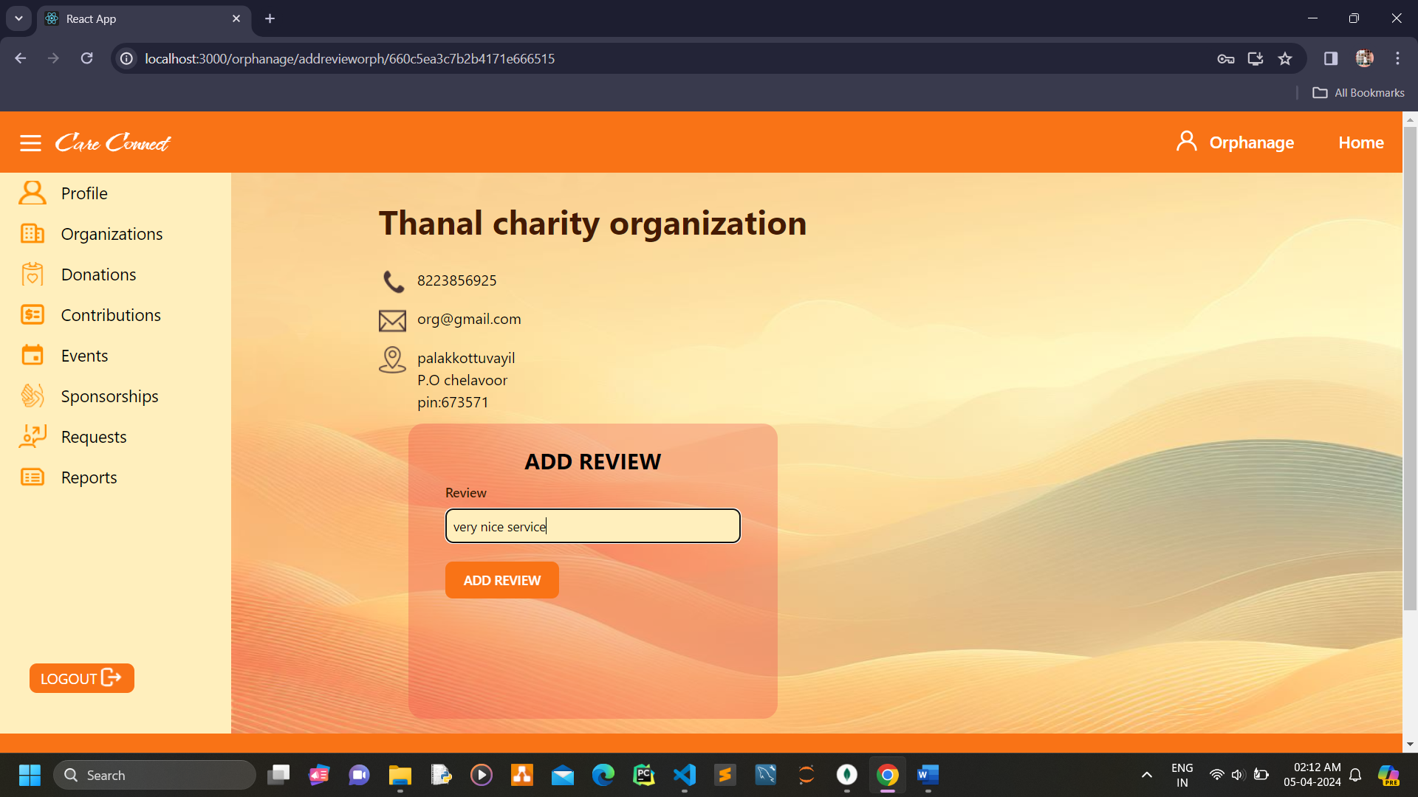

**Orphanage view donations**

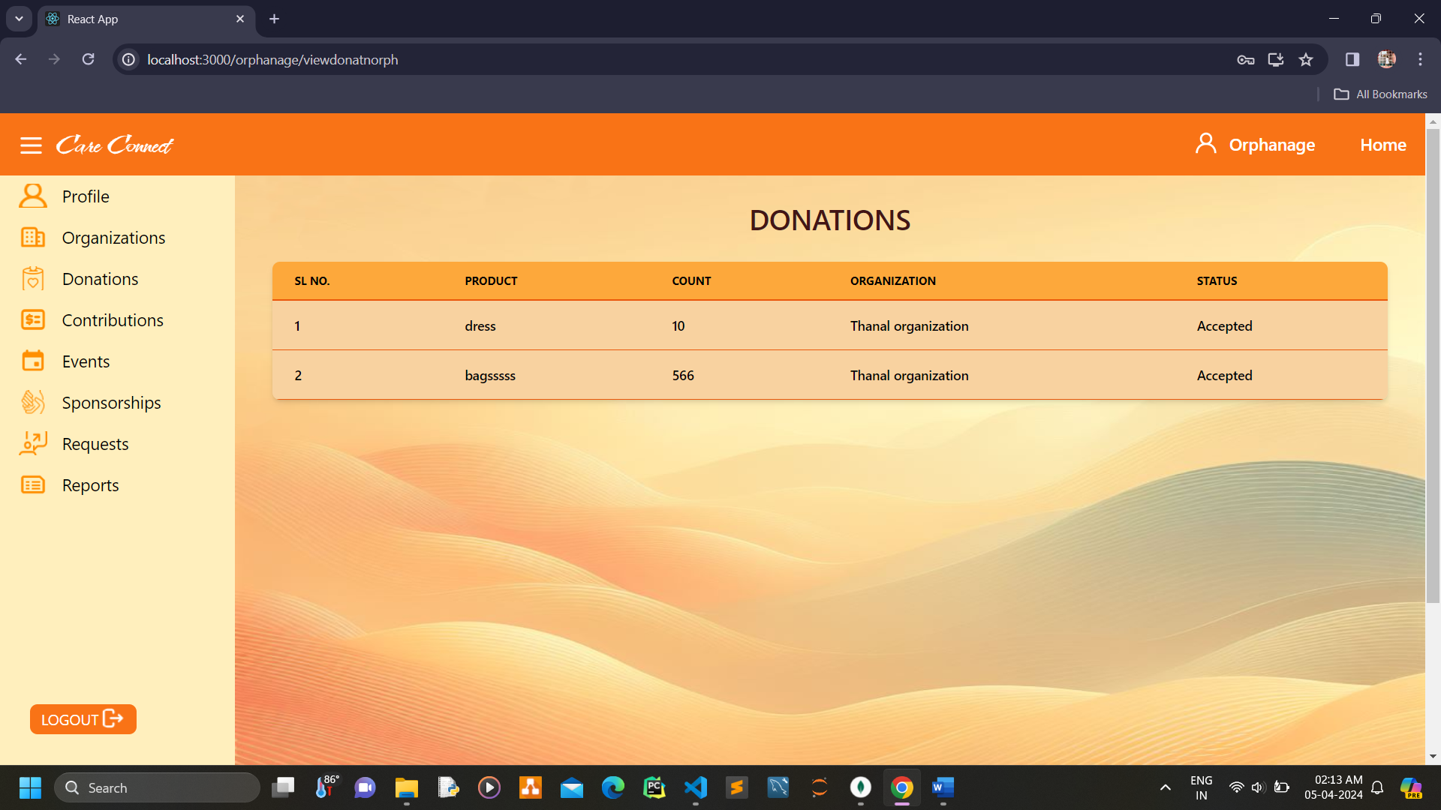

**Orphanage view contribution requests**

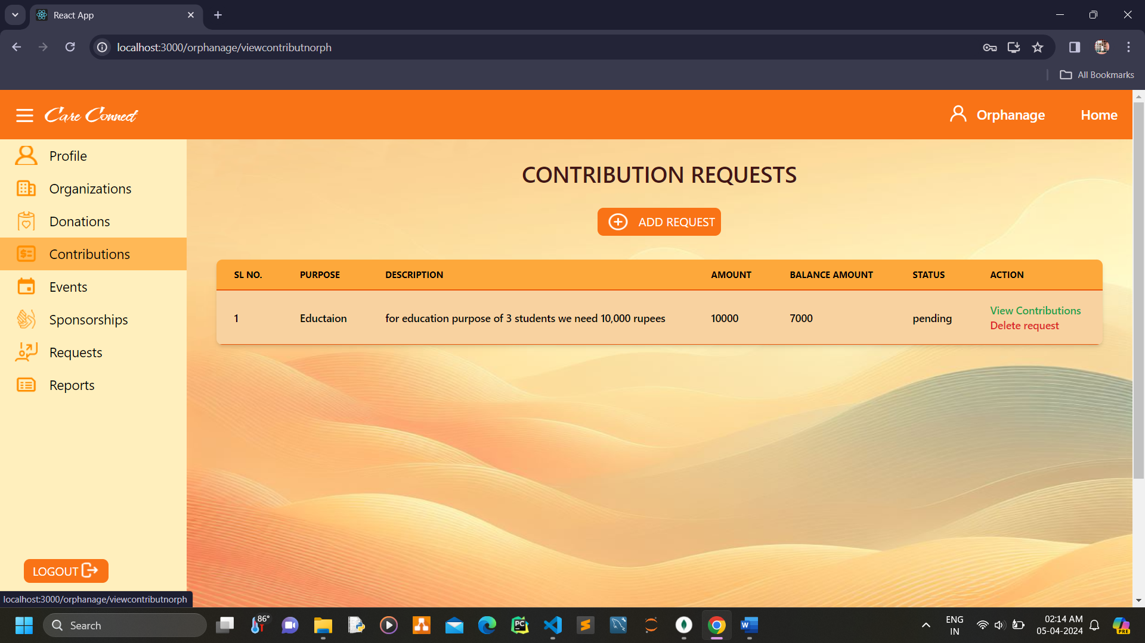

**Orphanage view contributions**

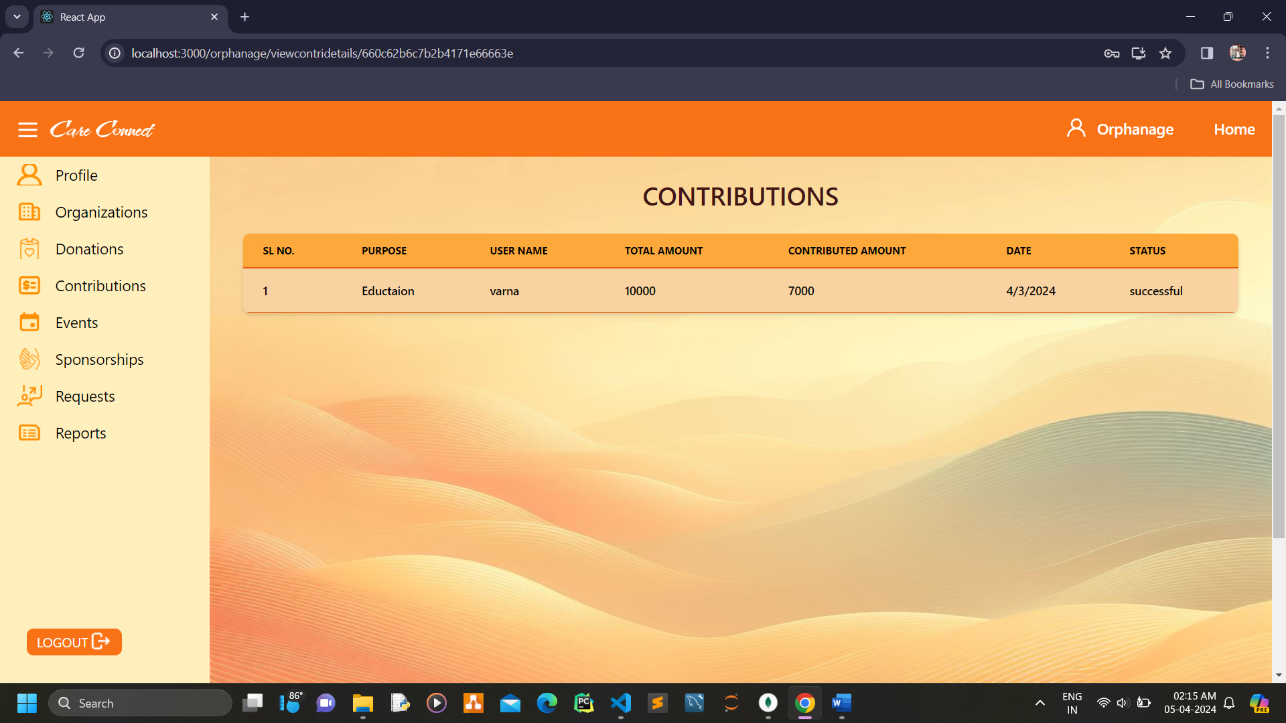

**Orphanage add contribution request**

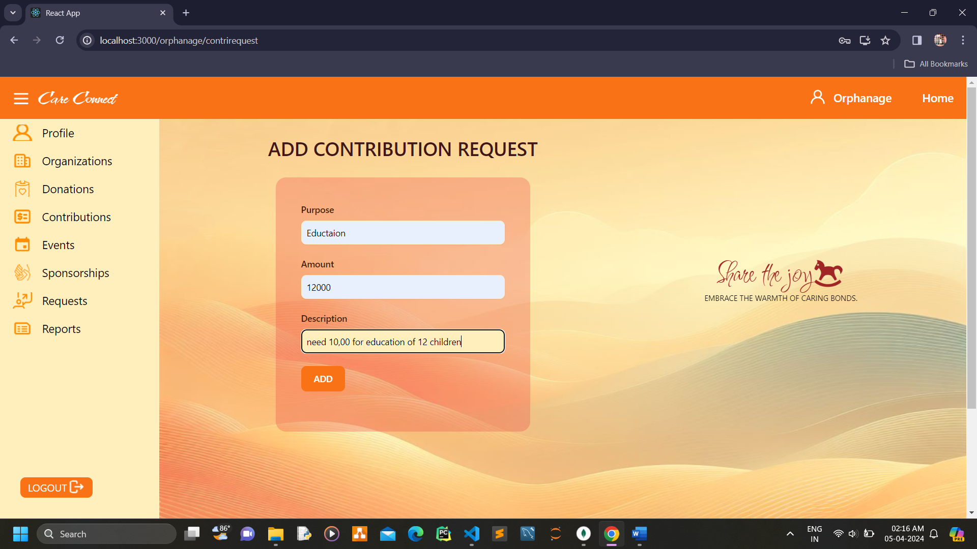

**Orphanage view events**

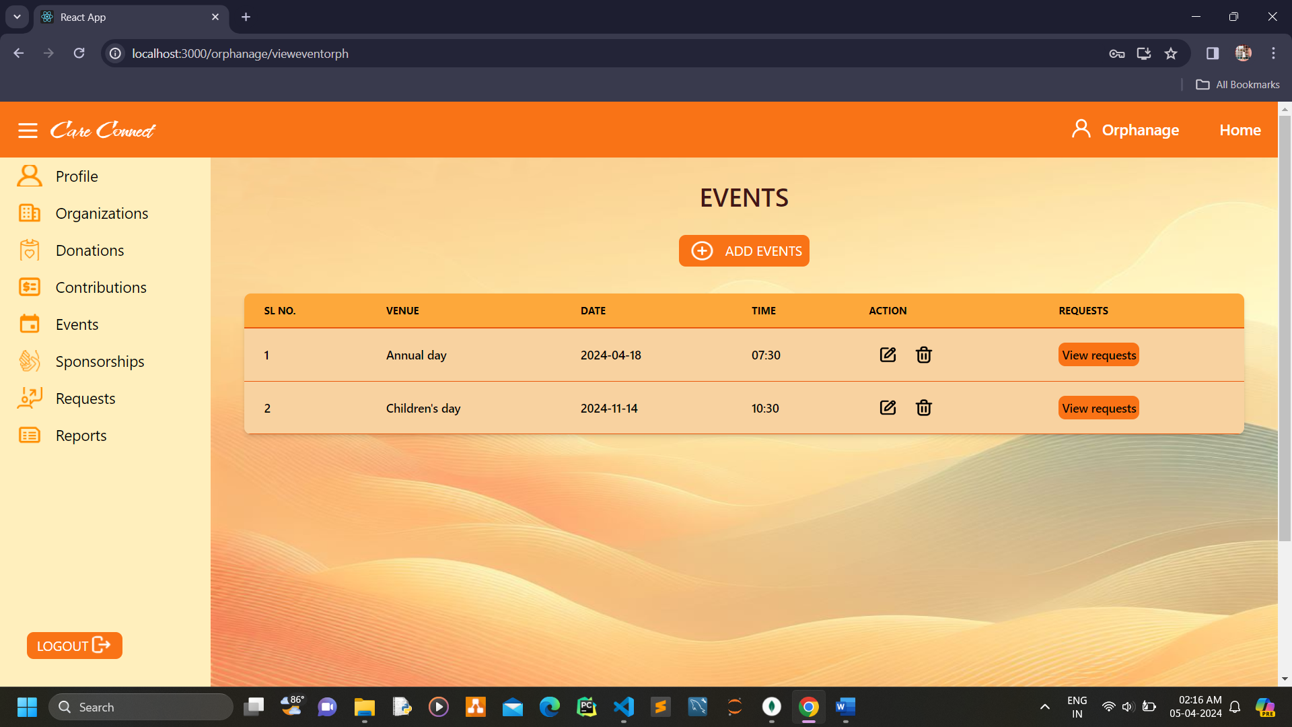

**Orphanage add events**

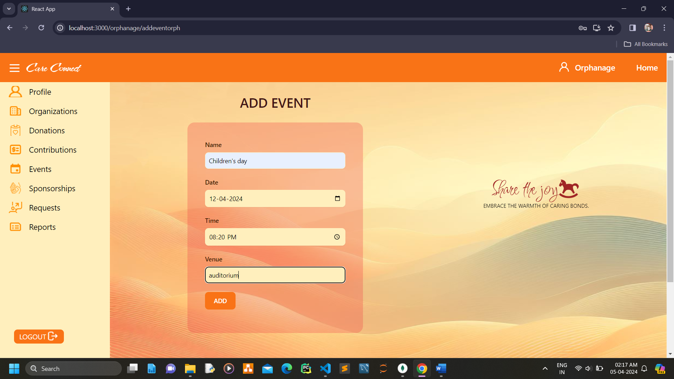

**Orphanage view sponsorship history**

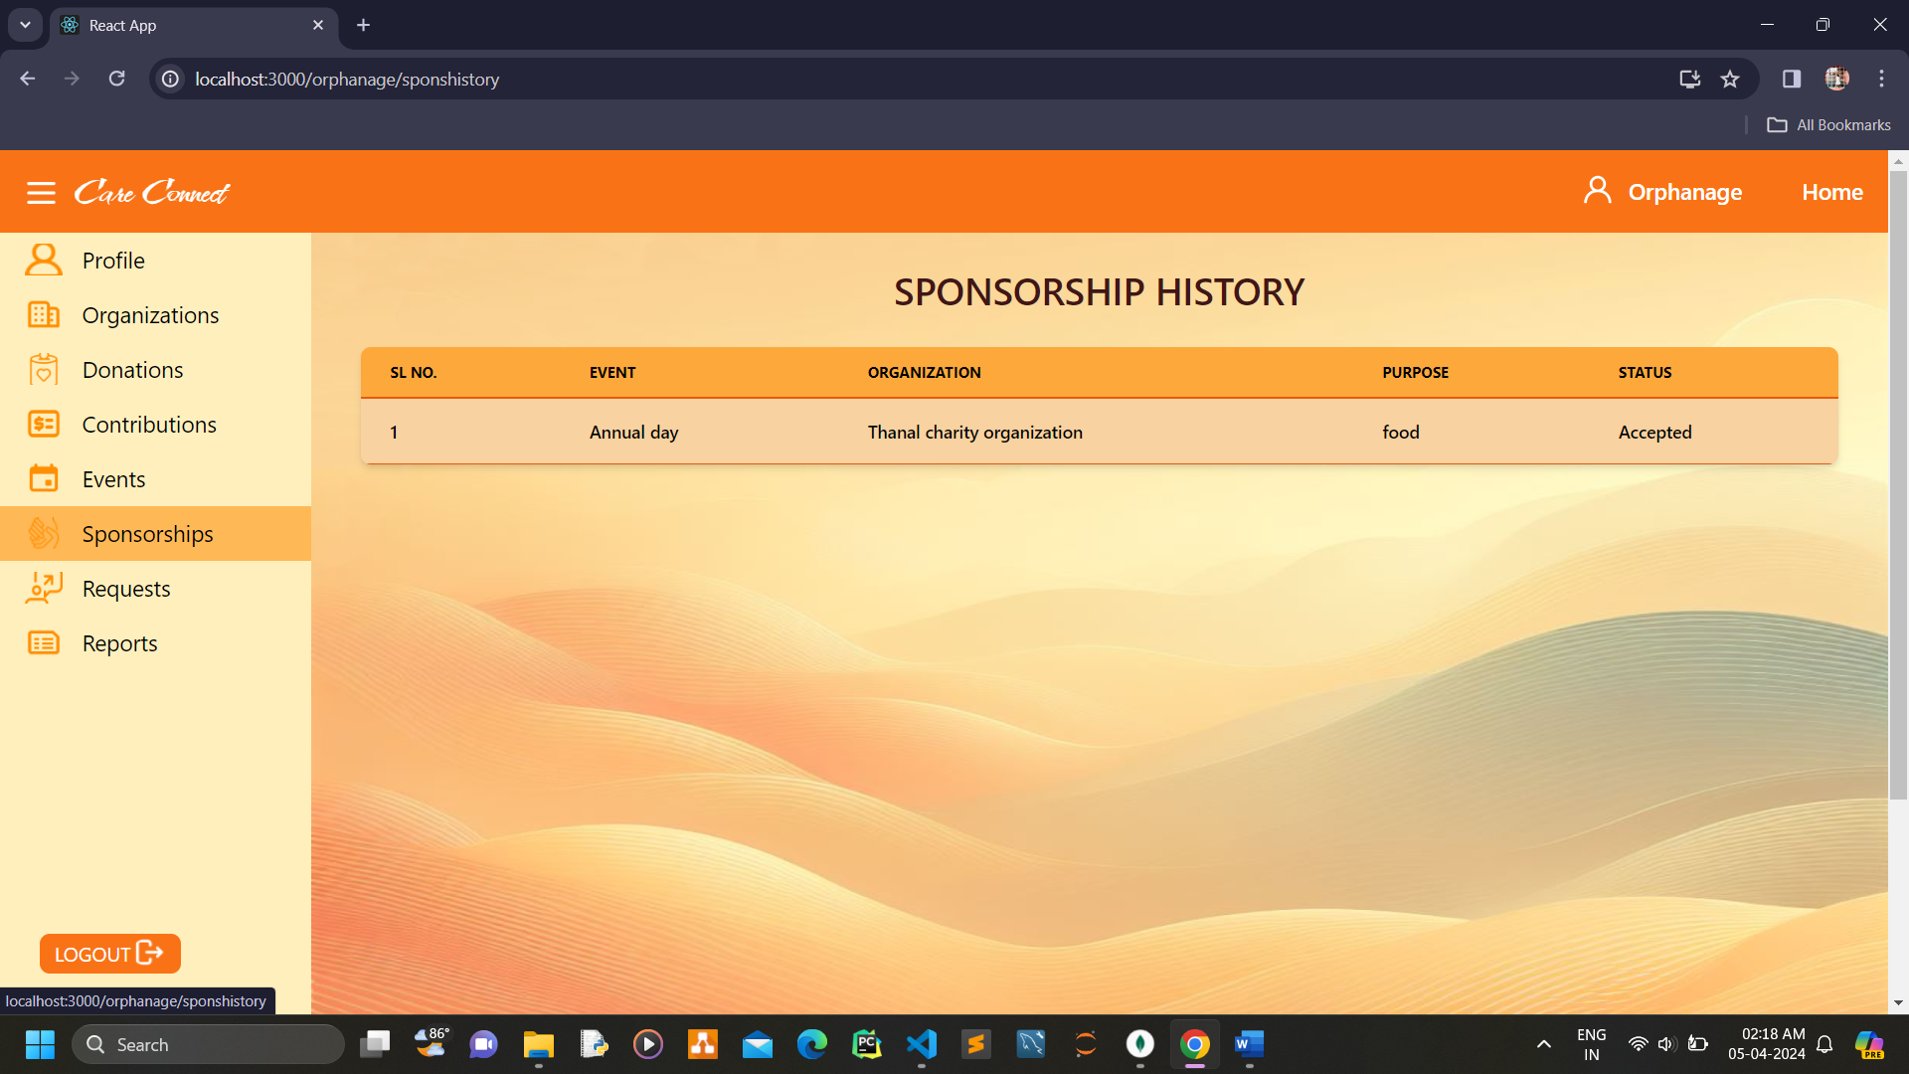

**Orphanage view donation requests**

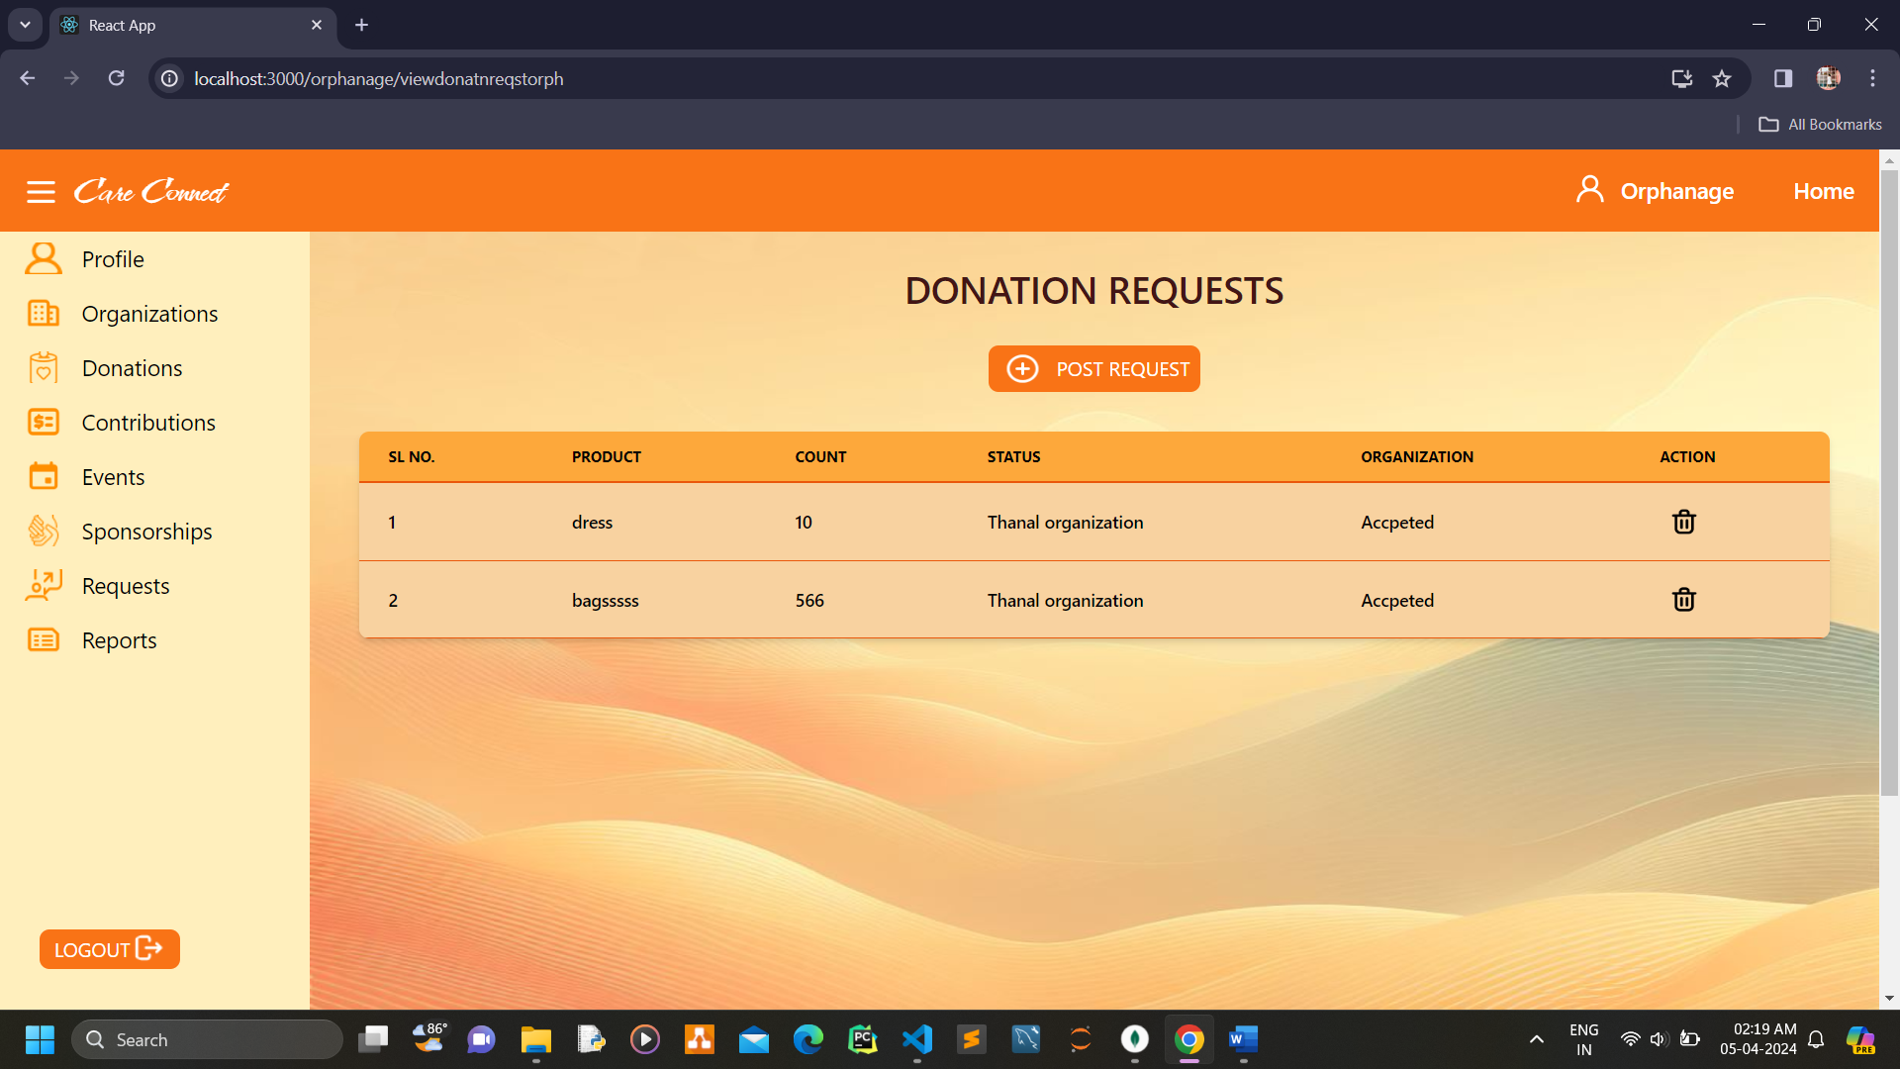

**Orphanage add donation requests**

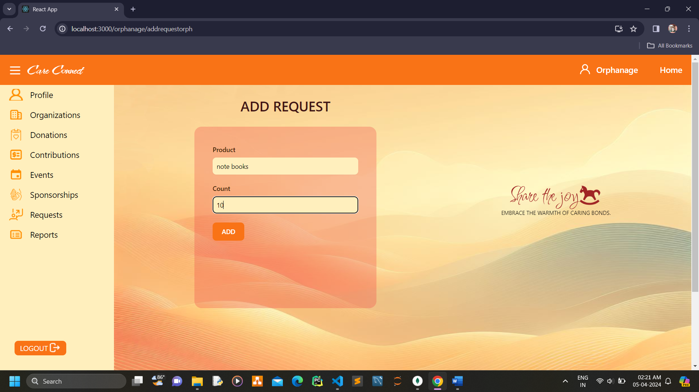

**Orphanage add report**

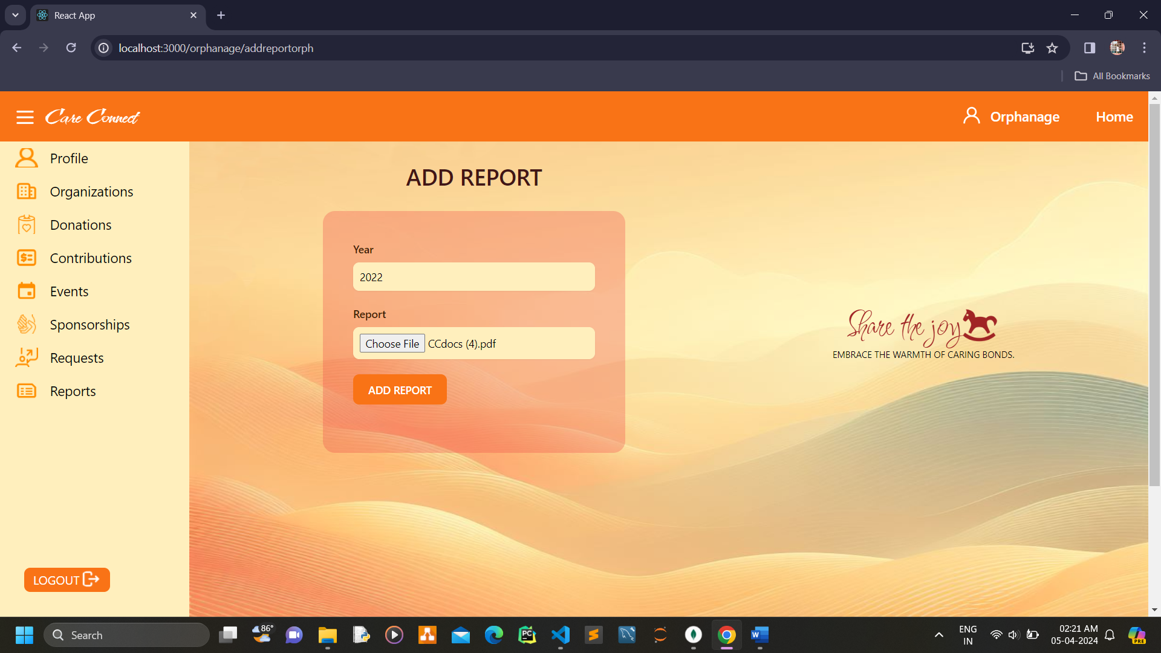

**Orphanage view report**

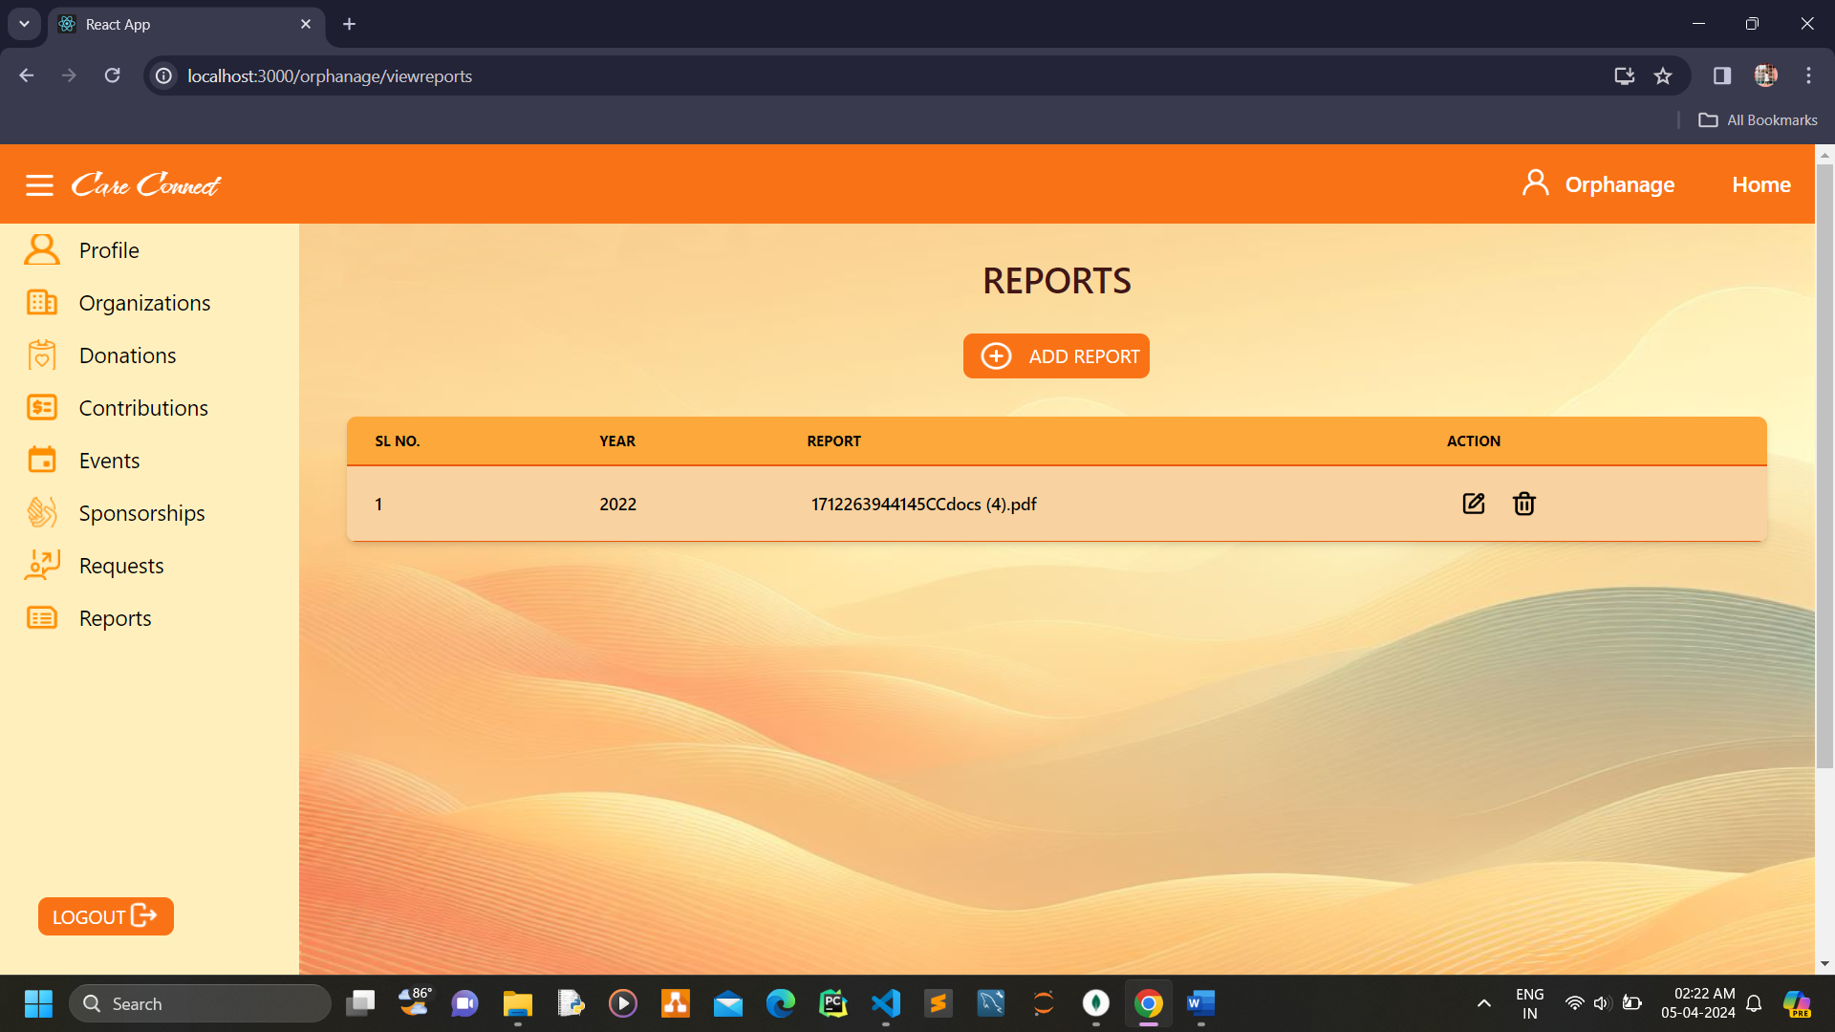

**User view and edit profile**

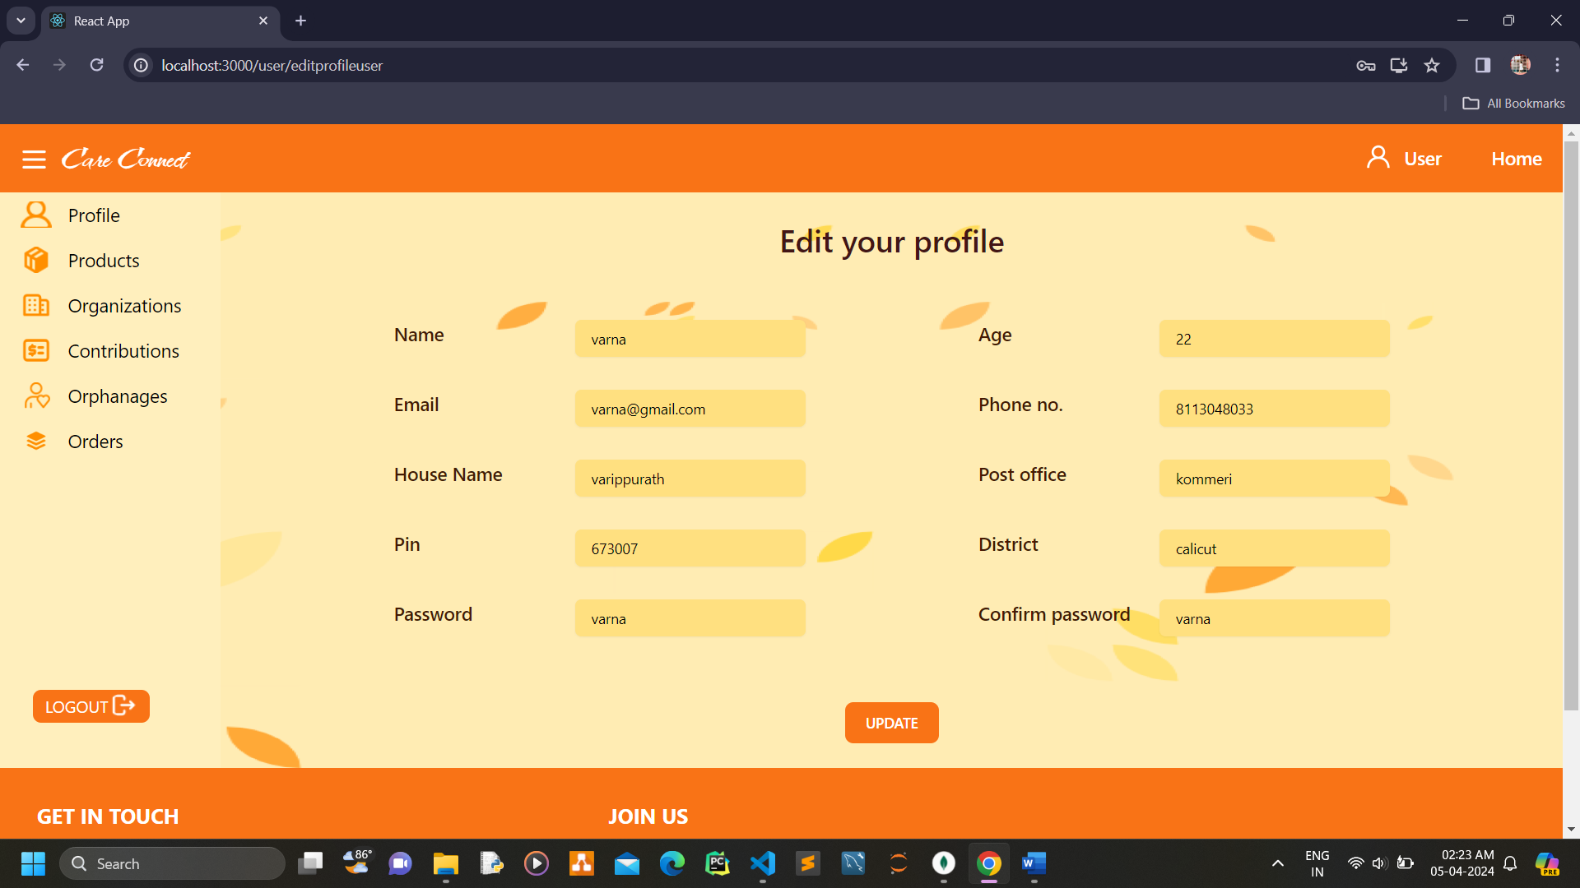

**User view products**

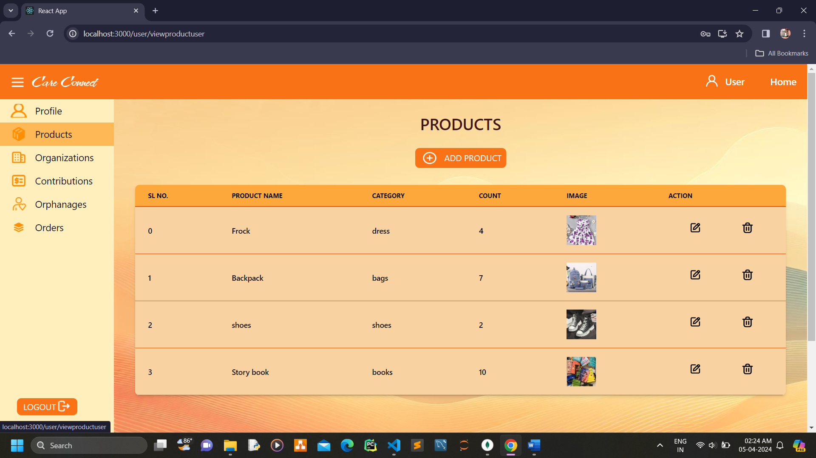

**User add products**

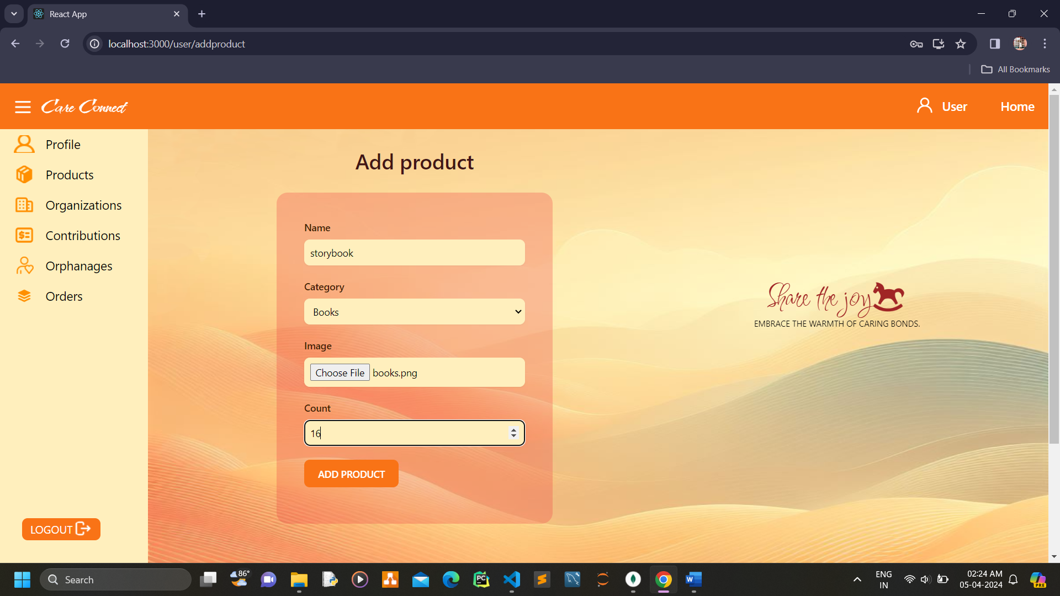

**User view organizations**

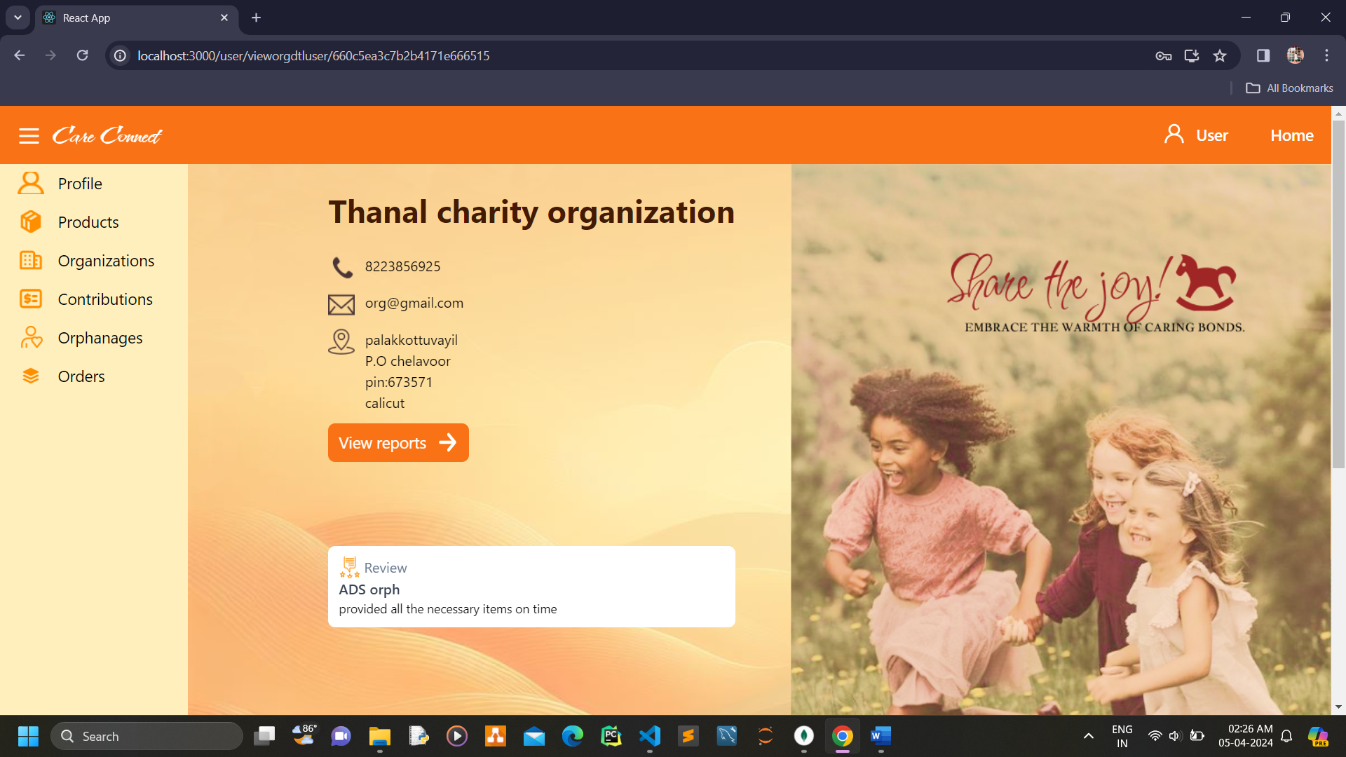

**User view contributions**

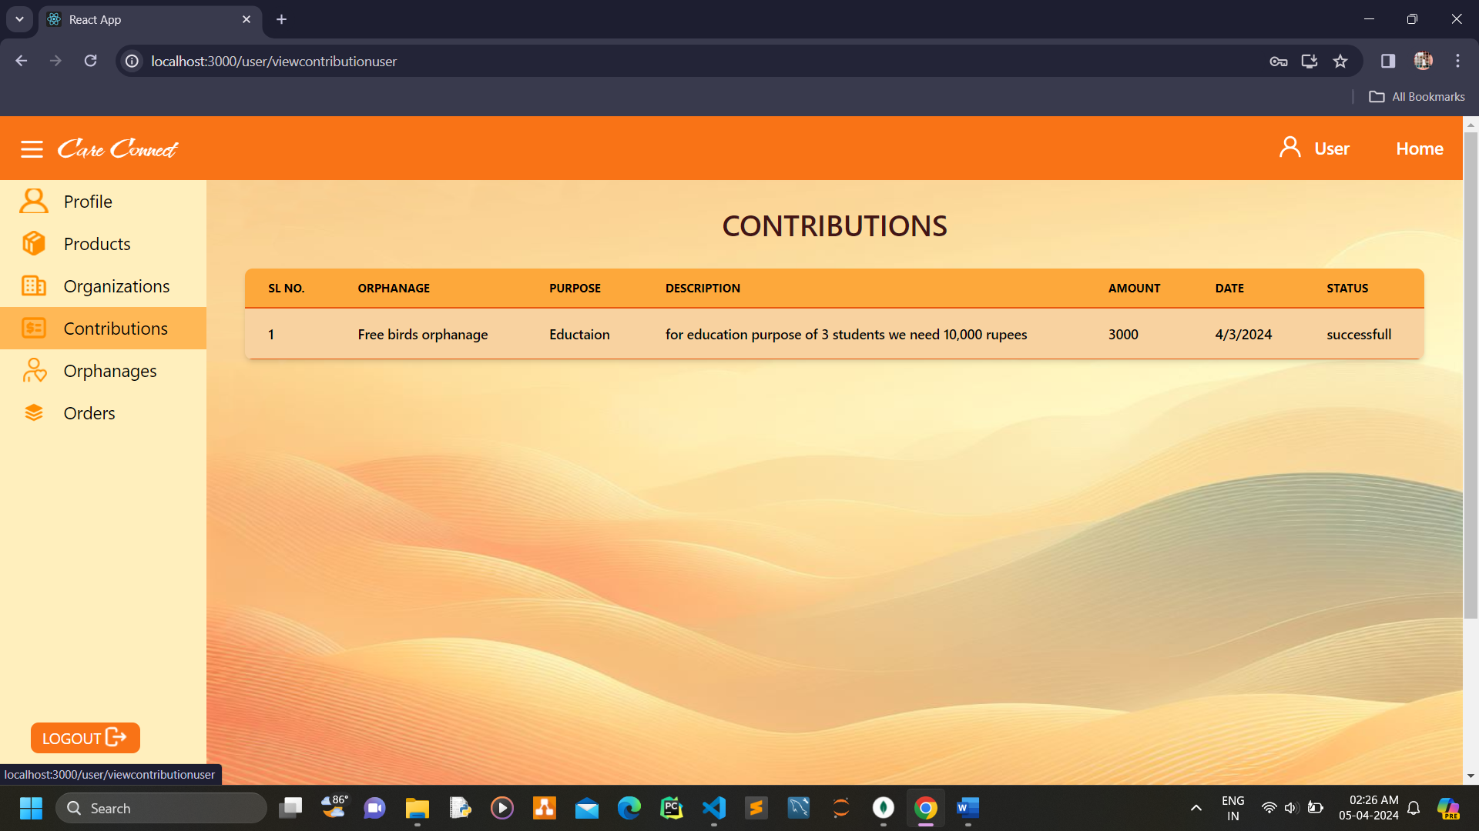

**User view orphanages**

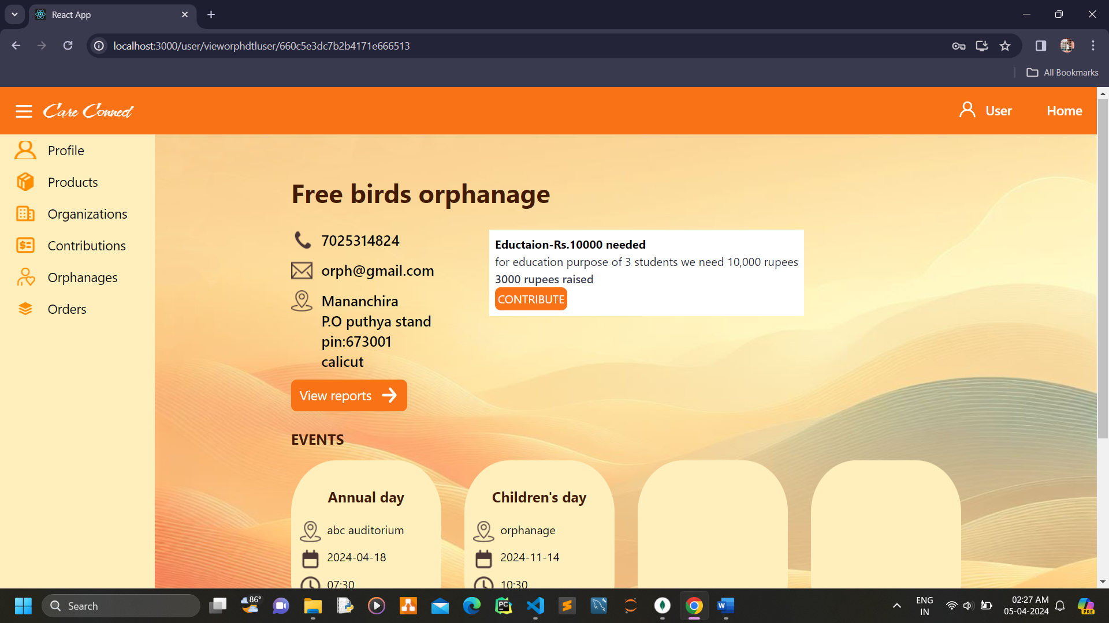

**User provide contribution**

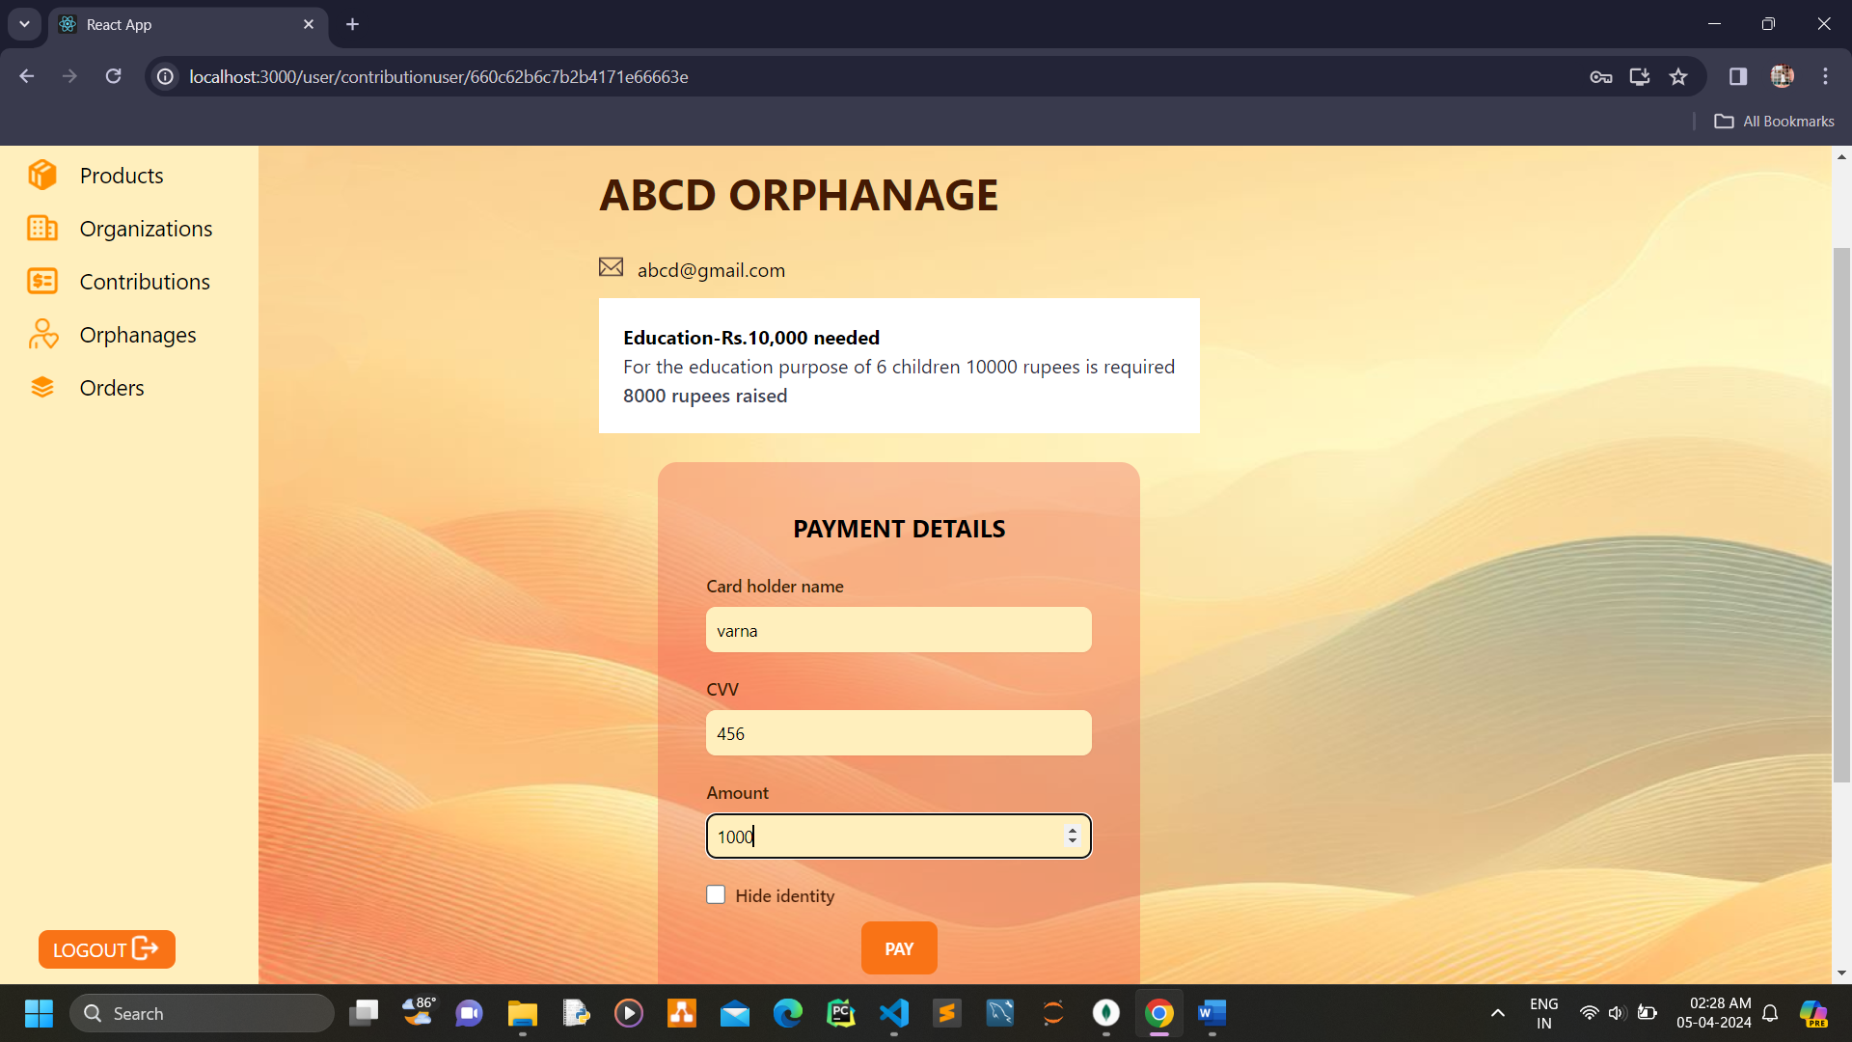

**User view orders**

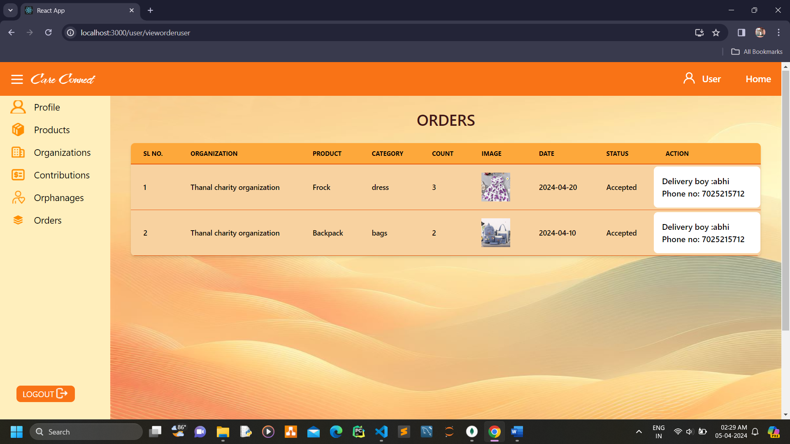

**Delivery boy view and edit profile**

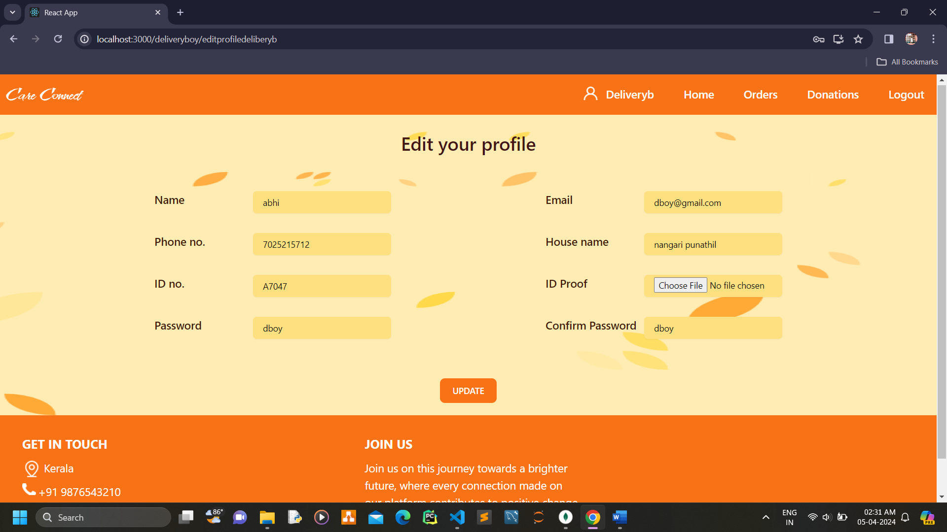

**Delivery boy update order status**

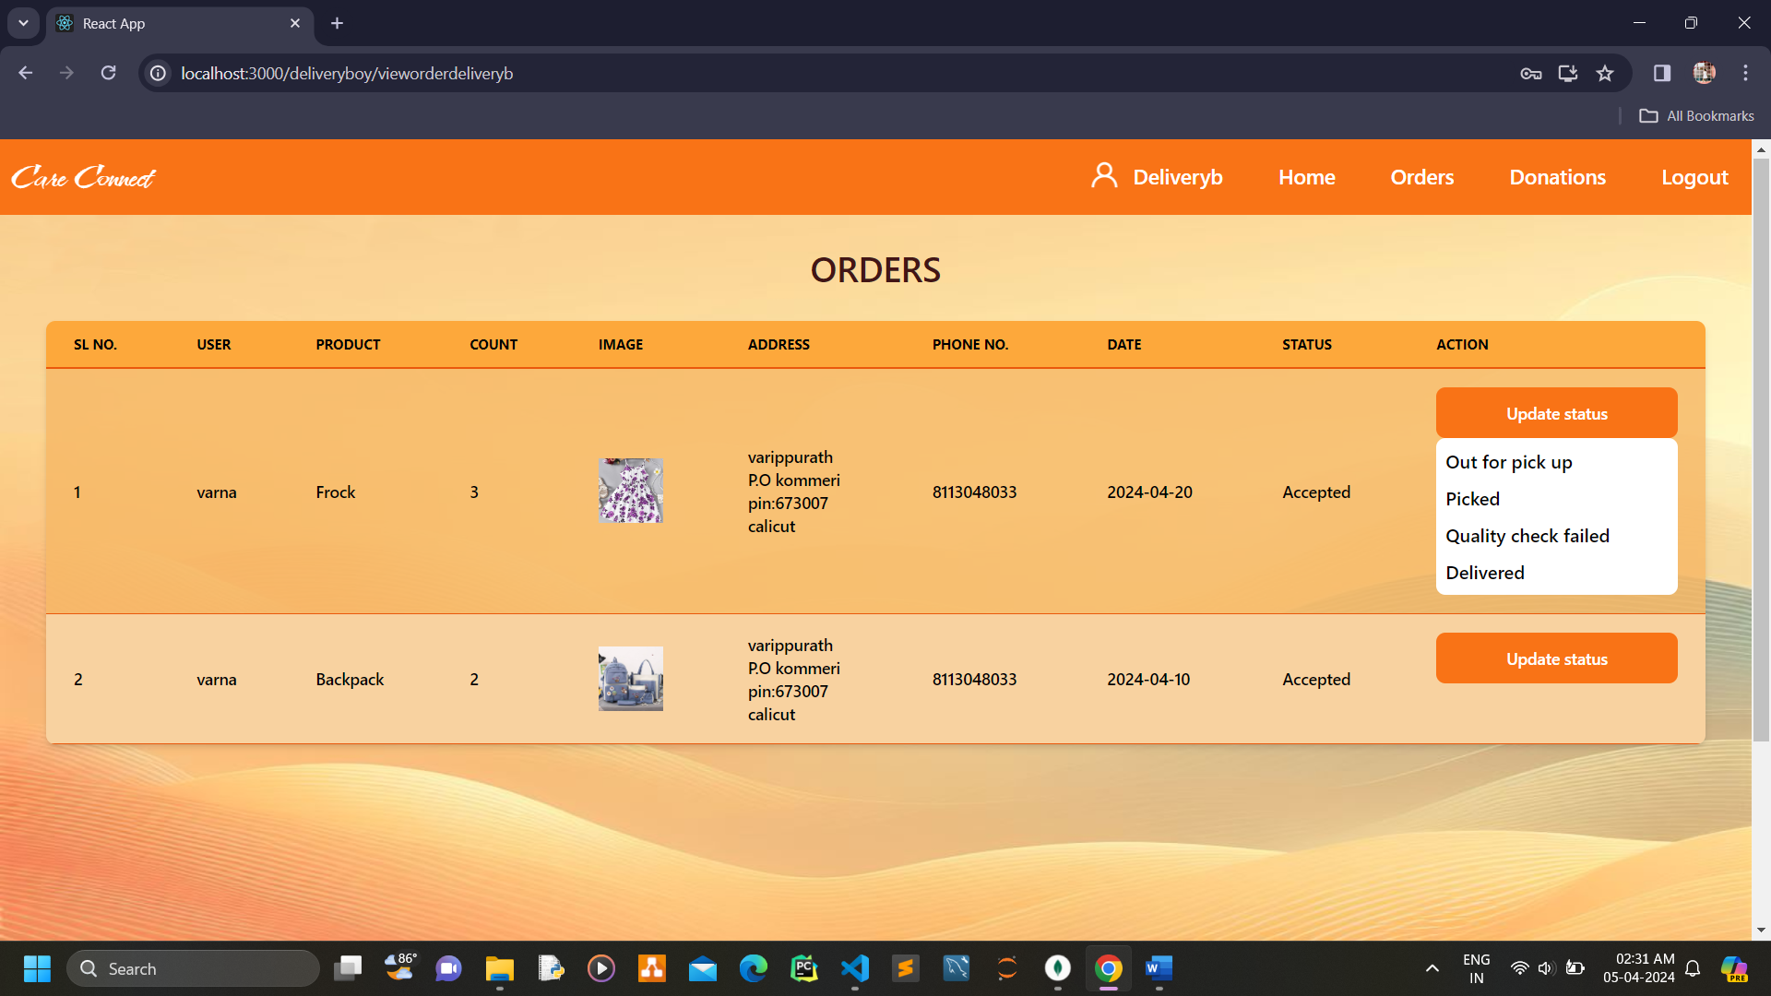

**Delivery boy update donation status**

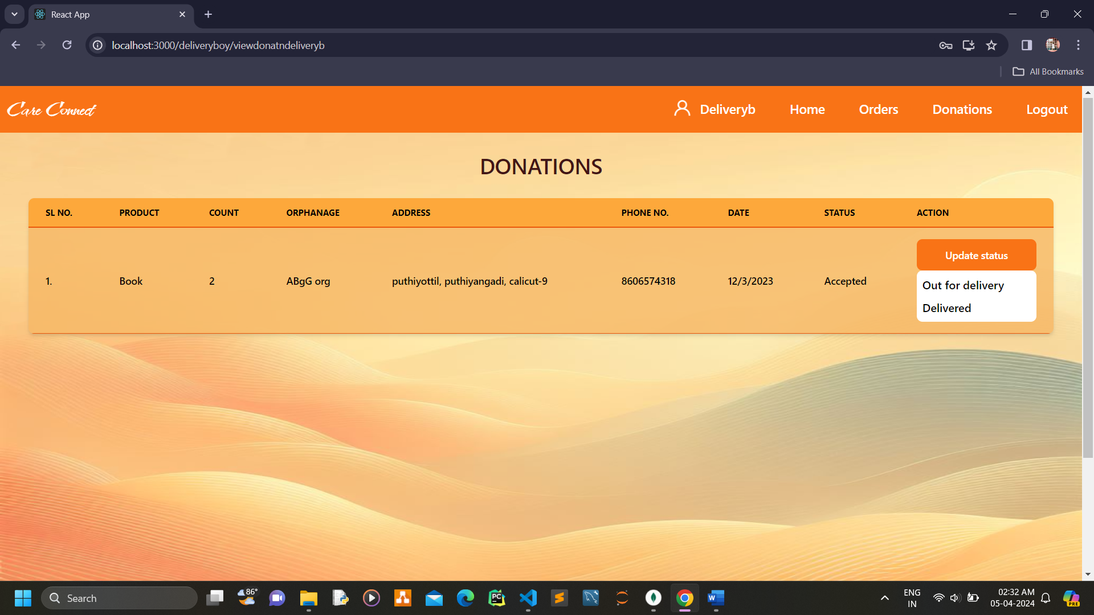

**BIBLIOGRAPHY**

### 13.BIBLIOGRAPHY

#### Websites

1. [*https://bootstrapmade.com*/*onepage-multipurpsode-bootstrap-template*](https://bootstrapmade.com/onepage-multipurpsode-bootstrap-template)
2. [*https://developer.mozilla.org/en-US/docs/Web/HTML*](https://developer.mozilla.org/en-US/docs/Web/HTML)
3. [*https://developer.mozilla.org/en-US/docs/Web/CSS*](https://developer.mozilla.org/en-US/docs/Web/CSS)
4. [*https://nodejs.org/en/docs*](https://nodejs.org/en/docs)
5. [*https://www.mongodb.com/docs*](https://www.mongodb.com/docs)

#### Books

[1] *Thomas A Powell, Fritz Schneider, “JavaScript: The Complete*

*Reference”, 3rd Edition,*  *Tata McGraw Hill*

[2] *Pro MERN Stack: Full Stack Web App Development with Mongo, Express, React, and Node" by Vasan Subramanian*

[3] *Code complete: a practical handbook of software construction by Steve McConnell, Microsoft Press,2nd Edition(2004).*

[4] *Full Stack Development with JHipster: Build scalable and maintainable web applications using the MERN stack" by Deepu K Sasidharan and Sendil Kumar N*

[5] *Full Stack JavaScript: Learn Backbone.js, Node.js, and MongoDB" by Azat Mardan*